BASIC LINUX COMMANDS
File Name | Oslab1 | Operating System | Linux
Experiment No | 1
Date | 26.4.2021
Aim | To familiarize with Linux commands for directory operations, displaying directory structure in tree format etc.
Theoretical Background:
ABOUT LINUX
Linux refers to the family of Unix-like computer operating systems using the Linux kernel. Linux can be installed on a wide variety of computer hardware, ranging from mobile phones, tablet computers and video game consoles, to mainframes and supercomputers. Linux is a leading server operating system, and runs the 10 fastest supercomputers in the world. Use of Linux by end-users or consumers has increased in recent years, partly owing to the popular Ubuntu, Fedora, and open SUSE distributions and the emergence of net books with pre- installed Linux systems and smart phones running embedded Linux.
The development of Linux is one of the most prominent examples of free and open
source software collaboration; typically all the underlying source code can be used, freely modified, and redistributed, both commercially and non-commercially, by anyone under licenses such as the GNU General Public License. Typically Linux is packaged in a format known as a Linux distribution for desktop and server use. Linux distributions include the Linux kernel and all of the supporting software required to run a complete system,sucha as utilities and libraries, the X Window System, the GNOME and KDE desktop environments, and the Apache HTTP Server. The name "Linux" comes from the Linux kernel,originally written In 1991 by
Linus Torvalds. The main supporting user space system tools and libraries from the GNU
Project are the basis for the Free Software Foundation's preferred name GNU/Linux.
BASIC FEATURES
Following are some of the important features of Linux Operating System.
- Portable − Portability means software can works on different types of hardware in same way. Linux kernel and application programs support their installation on any kind of hardware platform.
- Open Source − Linux source code is freely available and it is community based development project. Multiple teams work in collaboration to enhance the capability of Linux operating system and it is continuously evolving.
- Multi-User − Linux is a multiuser system means multiple users can access system resources like memory/ ram/ application programs at same time.
- Multiprogramming − Linux is a multiprogramming system means multiple applications can run at same time.
- Hierarchical File System − Linux provides a standard file structure in which system files/ user files are arranged.
- Shell − Linux provides a special interpreter program which can be used to execute commands of the operating system. It can be used to do various types of operations, call application programs. etc.
- Security − Linux provides user security using authentication features like password protection/ controlled access to specific files/ encryption of data.
Linux Distributions List
- There are on an average six hundred Linux distributors providing different features. Here, we'll discuss about some of the popular Linux distros today.
1) Ubuntu: It came into existence in 2004 by Canonical and quickly became popular. Canonical wants Ubuntu to be used as easy graphical Linux desktop without the use of command line. It is the most well known Linux distribution. Ubuntu is a next version of Debian and easy to use for newbie. It comes with lots of pre-installed apps and easy to use repositories libraries. Earlier, Ubuntu uses GNOME2 desktop environment but now it has developed its own unity desktop environment. It releases every six months and currently working to expand to run on tablets and smart phones.
2) Linux Mint: Mint is based on Ubuntu and uses its repository software so some packages are common in both.Earlier it was an alternative of Ubuntu because media codecs and proprietary software are included in mint but was absent in Ubuntu. But now it has its own popularity and it uses cinnamon and mate desktop instead of Ubuntu's unity desktop environment.

3) Debian: Debian has its existence since 1993 and releases its versions much slowly then Ubuntu and mint.This makes it one of the most stable Linux distributor.Ubuntu is based on Debian and was founded to improve the core bits of Debian more quickly and make it more user friendly. Every release name of Debian is based on the name of the movie Toy Story.

4) Red Hat Enterprise / CentOS: Red hat is a commercial Linux distributor. These products are red hat enterprise Linux (RHEL) and Fedora which are freely available. RHEL is well tested before release and supported till seven years after the release, whereas, fedora provides faster update and without any support. Red hat uses trademark law to prevent their software from being redistributed. CentOS is a community project that uses red hat enterprise Linux code but removes all its trademark and make it freely available. In other words, it is a free version of RHEL and provides a stable platform for a long time.

5) Fedora: It is a project that mainly focuses on free software and provides latest version of software. It doesn't make its own desktop environment but used 'upstream' software. By default it has GNOME3 desktop environment. It is less stable but provides the latest stuff.

Choosing a Linux Distribution
Distribution | When To Use
Ubuntu | It works like Mac OS and easy to use.
Linux mint | It works like windows and should be use by new comers.
Debian | It provides stability but not recommended to a new user.
Fedora | If you want to use red hat and latest software.
Red hat enterprise | To be used commercially.
CentOS | If you want to use red hat but without its trademark.
OpenSUSE | It works same as Fedora but slightly older and more stable.
Arch Linux | It is not for the beginners because every package has to be installed by yourself

LINUX FILE SYSTEM HIERARCHY
A file system is the way how system contains and stores all your files like your documents, games, programs, music, videos etc.In Linux world, the same theory holds true you have directories andfolders in which you arrange your files .Linux Directory Structure is totally different from windows. Linux Directory Structure is as shown in the figure.

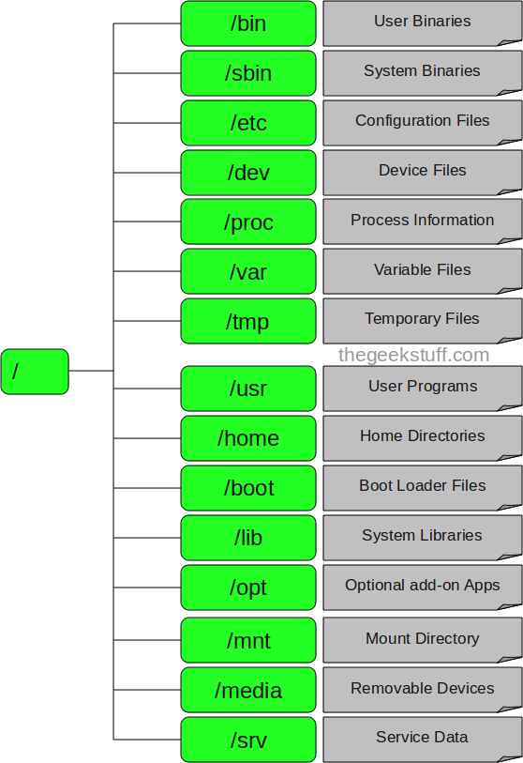

1. / – Root
- The Forward Slash (/) called root in Linux directory structure
- Every single file and directory starts from the root directory.
- Only root user has write privilege under this directory.
- Please note that /root is root user’s home directory, which is not same as /.

2 . /bin – User Binaries
- Contains binary executables.
- Common linux commands you need to use in single-user modes are located under this directory.
- Commands used by all the users of the system are located here.
- For example: ps, ls, ping, grep, cp,shell

3. /sbin – System Binaries
- Just like /bin, /sbin also contains binary executables.
- But, the linux commands located under this directory are used typically by system administrator, for system maintenance purpose.
- For example: iptables, reboot, fdisk, ifconfig, swapon

4. /etc – Configuration Files
- Contains configuration files required by all programs.
- This also contains startup and shutdown shell scripts used to start/stop individual programs.
- For example: /etc/resolv.conf, /etc/logrotate.conf

5. /dev – Device Files
- Contains device files.
- Devices and hardwares are treated as files that are available to a Linux system.If you attached floppy drive, you will find it under this path /dev/fd0, hard drive will be accessible under this location /dev/had (first IDE hard drive), CD drive located under /dev/cdrom drive, and so on.
- For example: /dev/tty1, /dev/usbmon0

6. /proc – Process Information
- Contains information about system process.
- This is a pseudo filesystem contains information about running process. For example: /proc/{pid} directory contains information about the process with that particular pid.
- This is a virtual file system with text information about system resources. For example: /proc/uptime

7. /var – Variable Files
- var stands for variable files.
- Content of the files that are expected to grow can be found under this directory.
- System and program log files
- This includes — system log files (/var/log); packages and database files (/var/lib); emails (/var/mail); print queues (/var/spool); lock files (/var/lock); temp files needed across reboots (/var/tmp);

8. /tmp – Temporary Files
- Directory that contains temporary files created by system and users.
- Files under this directory are deleted when system is rebooted.

9. /usr – User Programs
- This is one of the most significant directories in the system as it contains all the user binaries, their documentation, libraries, header files, etc.
- Contains binaries, libraries, documentation, and source-code for second level programs.
- /usr/bin contains binary files for user programs. If you can’t find a user binary under /bin, look under /usr/bin. For example: at, awk, cc, less, scp.
- /usr/sbin contains binary files for system administrators. If you can’t find a system binary under /sbin, look under /usr/sbin. For example: atd, cron, sshd, useradd, userdel.
- /usr/lib contains libraries for /usr/bin and /usr/sbin.
- /usr/local contains users programs that you install from source. For example, when you install apache from source, it goes under /usr/local/apache2

10. /home – Home Directories
- This directory contains user’s personal files and folders. Every user has their directory under /home and they allowed saving and deleting files in their appropriate directory. This directory is equivalent to windows â C:\Document and Setting\ folder.
- Home directories for all users to store their personal files.
- For example: /home/john, /home/nikita

11. /boot – Boot Loader Files
- Contains boot loader related files.
- Kernel initrd, vmlinux, grub files are located under /boot
- For example: initrd.img-2.6.32-24-generic, vmlinuz-2.6.32-24-generic

12. /lib – System Libraries
- Contains library files that supports the binaries located under /bin and /sbin
- Library filenames are either ld* or lib*.so.*
For example: ld-2.11.1.so, libncurses.so.5.7

13. /opt – Optional add-on Applications
- opt stands for optional.
- Contains add-on applications from individual vendors.
- add-on applications should be installed under either /opt/ or /opt/ sub-directory.

14. /mnt – Mount Directory
- /mnt directory is contains mount points. Some physical storage hardware and devices like the hard disk drives, floppies, CD-ROM’s must be attached to some directory in the file system tree before they can be accessed. This attaching is called mounting, and the directory where the device is attached is called the mount point. The /mnt directory contains mount point for these devices, like /mnt/cdrom for CD-ROM, /mnt/floppy for floppy drive, and so on. However, you can use other directory as mount point instead of using /mnt.
- Temporary mount directory where sysadmins can mount filesystems.

15. /media – Removable Media Devices
- Temporary mount directory for removable devices.
- For examples, /media/cdrom for CD-ROM; /media/floppy for floppy drives; /media/cdrecorder for CD writer

16. /srv – Service Data
- srv stands for service.
- Contains server specific services related data.
- For example, /srv/cvs contains CVS related data
BASIC COMMANDS
Name: date
Syntax: date
Description: To print and set system date and time
Name: time
Syntax: date
Description: Displays current time and date. If you are interested only in time, you can use 'date +%T'
Name: cal
Syntax:cal
Description: Displays the calendar of the current month
Name: whatis
Syntax: whatis <command>
Description: This command gives a one line description about the command. It can be used as a quick reference for any command.
Name: whoami
Syntax: whoami
Description:This command reveals the user who is currently logged in.
Name: clear
Syntax:clear
Description:This command clears the screen
Name: man
Syntax: man<command>
Description: To see a command's manual page, man command is used.
Files and Directory related commands
Directory operations
Name: cd
Syntax: cd [directory]
Description: The current working directory to the directory specified by "directory".
Example: enter the directory / usr / bin /: cd / usr / bin
Name: ls
Syntax: ls [options] [pathname-list]
Description: display the file name within the directory and file name specified in the "pathname-list"
Example: List all names in the current working directory is s at the beginning of the file: ls s *
Name: pwd
Syntax: pwd
Description: Displays the absolute path of the current directory.
Name: mkdir
Syntax: mkdir [options] dirName
Description: create name is dirName subdirectory.
Example: In the working directory, create a subdirectory named AA: mkdir AA
Name: rmdir
Syntax: rmdir [-p] dirName
Description: delete empty directories.
Example: to delete the working directory, subdirectory named AA: rmdir AA 2 file operations
Name: cp
Syntax: cp [options] file1 file2
Description: Copy the file file1 to file2. Common options:-r copy the entire directory Example: aaa copy (existing), and named bbb: cpaaabbb
Name: mv
Syntax: mv [options] source ... directory
Description: Rename the file, or the number of files to another directory. Example: aaa renamed as bbb: mv aaabbb
Name: rm
Syntax: rm [options] name...
Description: delete files and directories. Commonly used options:-f to force delete files
Example: Remove all but the suffix named c file rm *. C
Name: cat
Syntax: cat [options] [file-list]
Description: standard output connection, display a list of files in the file-list file
Example 1: Displays the contents of file1 and file2 - cat file1 file2
Example 2: file1 and file2 merged into file3 - cat file1 file2> file3
Name: head
Syntax: head [options] [file-list]
Description: Display the initial part of the file in the list of files in the file-list, the default display 10 lines;
Example: the initial part of the file AAA head AAA
Name: tail
Syntax: tail [options] [file-list]
Description: Displays the tail of the list of files in the file-list file; default display 10 lines;
Example: tail file AAA tail AAA
Name: echo
Syntax: echo $ variable
Description: Displays the value of the variable variable.
Example 1: Display the current user's PATH value echo $ PATH
Name: ps
Syntax: $ ps [options]
Description: The active process is used to view the current system
Example 1: display all current processes ps-aux
Name: file
Syntax:file<pathname>
Description: This command is used to find the type of the file.
Name: sort
Syntax: sort [OPTIONS]
Description: The Linux sort command can be used to sort the contents of a file in a number of ways. By default, the Linux sort command sorts the contents in alphabetical order depending on the first letter in each line. For example, the sort /etc/passwd command would sort all users by username.
Important options of the sort are

•-b (Ignores spaces at beginning of the line)
•-d (Uses dictionary sort order and ignores the punctuation)
•-f (Ignores caps)
•-i (Ignores nonprinting control characters)
•-m (Merges two or more input files into one sorted output)
•-r (Sorts in reverse order)
• -u (If line is duplicated only display once)
Name:wc
Syntax:wc[OPTIONS]
Description: The Linux wc (word count) command, can return the number of lines, words, and characters in a file. Important options of the Linux wc command are
•-c (Print the byte counts)
•-m (Print the character counts)
•-l (Print the new line counts)
• -w (Print the word counts)
OUTPUT

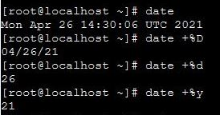

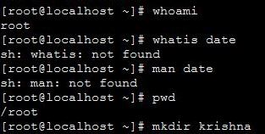

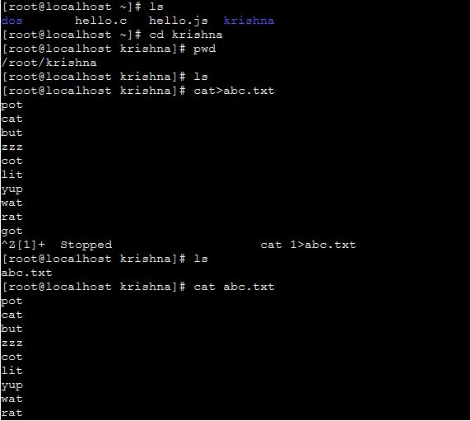
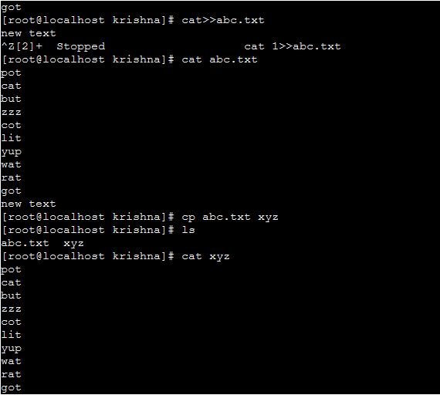
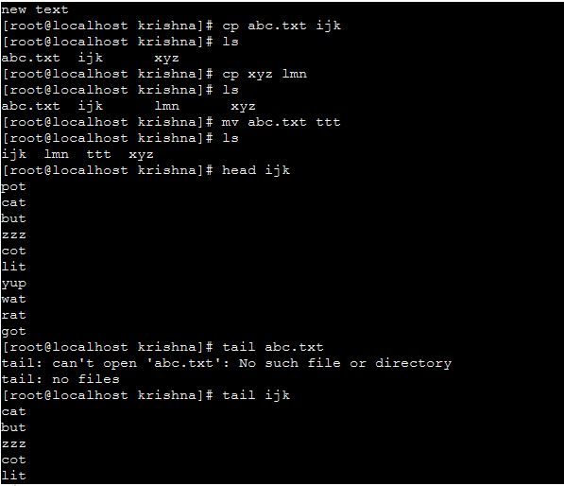
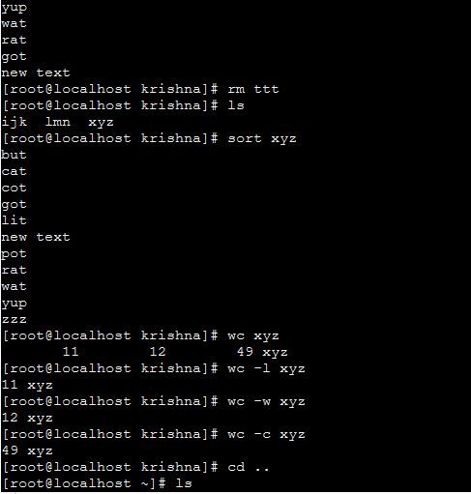
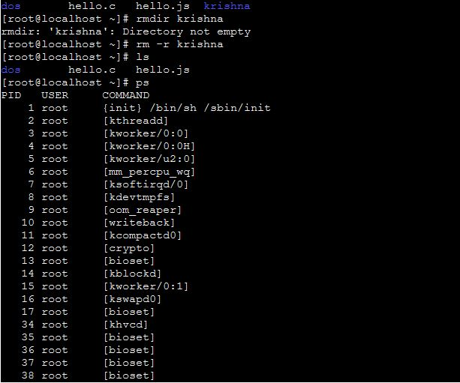
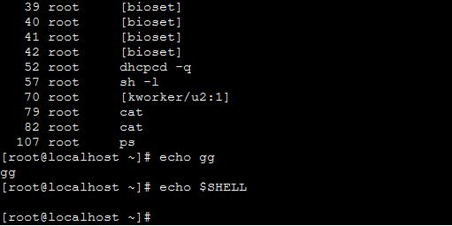

RESULT

Familiarized with the basic linux commands.

SHELL PROGRAMMING
File Name | Oslab2 | Operating System | Linux
Experiment No | 2
Date | 3.5.2021
Aim | To develop shell scripts with simple functions with basic test,loops and patterns.
THEORETICAL BACKGROUND:
A shell is software the gives a user interface to various operating system functions and services. So in other words your interface to operating system is called shell. Shells provide a way for you to communicate with the operating system. This communication is carried out either interactively input from the keyboard is acted upon immediately or as a shell script.
The UNIX shell program interprets user commands, which are either directly entered by the user, or which can be read from a file called the shell script or shell program. (ieA shell script is a file that contains ASCII text .ie a script is a human-readable text file containing a group of commands that could also be manually executed one-by-one at the LINUX operating system command prompt. They are often kept in a file (script) because they are too numerous to type in at the command prompt each time you want to perform a specific task, or because together they form a complex computer program..)Shell scripts are interpreted, not compiled. The shell reads commands from the script line per line and searches for those commands on the system (see Section 1.2), while a compiler converts a program into machine readable form, an executable file - which may then be used in a shell script.
Apart from passing commands to the kernel, the main task of a shell is providing a user environment, which can be configured individually using shell resource configuration files.
Shell types
Just like people know different languages and dialects, your UNIX system will usually offer a variety of shell types.
In UNIX there are two major types of shells:
• The Bourne shell. If you are using a Bourne-type shell, the default prompt is the $ character.
• The C shell. If you are using a C-type shell, the default prompt is the % character.
There are again various subcategories for Bourne Shell which are listed as follows −
• Bourne shell ( sh): the original shell still used on UNIX systems and in UNIX-related environments. This is the basic shell, a small program with few features. While this is not the standard shell, it is still available on every Linux system for compatibility with UNIX programs.
• Korn shell (ksh): sometimes appreciated by people with a UNIX background. A superset of the Bourne shell; with standard configuration a nightmare for beginning users.
• Bourne again shell (bash): the standard GNU shell, intuitive and flexible. Probably most advisable for beginning users while being at the same time a powerful tool for the advanced and professional user. On Linux, bash is the standard shell for common users. This shell is a so-called superset of the Bourne shell, a set of add-ons and plug-ins. This means that the Bourne Again shell is compatible with the Bourne shell: commands that work in sh, also work in bash. However, the reverse is not always the case. All examples and exercises in this book use bash.
• POSIX shell ( sh)
The different C-type shells follow −
• C shell (csh): the syntax of this shell resembles that of the C programming language. Sometimes asked for by programmers.
• TENEX/TOPS C shell (tcsh): : a superset of the common C shell, enhancing user-friendliness and speed. That is why some also call it the Turbo C shell.
The file /etc/shells gives an overview of known shells on a Linux system:
<to include screenshot>
Your default shell is set in the /etc/passwd file
<to include screenshot>
To switch from one shell to another, just enter the name of the new shell in the active terminal. The system finds the directory where the name occurs using the PATH settings, and since a shell is an executable file (program), the current shell activates it and it gets executed. A new prompt is usually shown, because each shell has its typical appearance:
Writing a script
To successfully write a shell script, you have to do three things:
1. Write a script
2. Give the shell permission to execute it
3. Put it somewhere the shell can find it
To create a shell script, you use a text editor. A text editor is a program, like a word processor, that reads and writes ASCII text files. There are many, many text editors available for your Linux system, both for the command line environment and the GUI environment. Here is a list of some common ones:

bash shell scripting fundamentals
• Shell definition line :The first line in your script must be#!/bin/bash
... that is a # (Hash) followed by a ! (bang) followed by the path of the shell. This line lets the environment know the file is a shell script and the location of the shell.
• The name of your shell script must end with a .sh . This lets the user know that the file is a shell script. This is not compulsory but is the norm.
• Before executing your script, you should make the script executable. You do it by using the following command:
$ chmodugo+x your_shell_script.sh
• Shell Script Comments: Comments, or non-command code, in a shell script begin with the # (pound) character and can be used for different purposes. They may be used to document what the overall purpose of the script is, to describe what each line of program code does, to track modifications made to the script and who made them, or for a number of other purposes. The comment character (#) may appear on any line of the script, may appear by itself on a line, or may follow actual program code. Both of these lines from the example shell script are valid program comments:
#This is a comment on a line by itself
clear # This comment is sharing the line with the clear command
As the text in the comment lines indicate, the first comment does not share the line with anything else, and the second comment shares a line with the UNIX clear command.
• Displaying Output:The example shell script above shows two methods for displaying output to standard output:
echo"TextLine1"
print "Text Line 2"
Many people are familiar with the echo command, but the print command may be new to them. The print command is the replacement for the echo command. You should use the print command when you are writing shell scripts because it is more powerful than the echo command, and its syntax has been standardized on multiple operating systems. The print and echo commands are often used to display interactive messages to the person running the script, write informational or error messages to a log file, or to write data to a data file.
• Exiting a Shell Script: All shell scripts should be terminated with the exit command: exit 0.The word "should" is used here because a script will run successfully without including it, but it is good to get in the habit of including exit in your scripts.You will notice that the exit command is passed an argument of 0 (the number zero). Most UNIX commands and programs will return a number, called the return code, to the parent process.
It is common practice to return a 0 (zero) if the command or program completed successfully, and a non-zero number if it did not. The non-zero number will in most cases be a 1 (the number one), but may be another non-zero number to give a more specific indication of why the command or Program failed.
NOTE: If a number is not specified with the exit command, the return code of the last command executed in the script will be returned to the parent process. If 0 (zero) was not specified in the example script, the return code for the print command would be returned to the parent process.
• How to Run a Shell Script: Different methods can be used to run (execute) a shell script. You can run the script in the current shell, or you can spawn (create) a new shell to run the script in. If you run a script containing the exit command in the current shell, you will be logged out of the system when the script executes the exit command. Before you can run the script, you need to make the shell script file an executable by using the UNIX chmod command. The following command will allow only the user (owner) of the script to execute it:
$ chmodu+x script1.sh
If you wanted to allow everyone (all) to execute the script, you would use this command:
$ chmoda+x script1.sh
After the script file has been made an executable with the chmod command, you can run the script in a new shell by giving the path to the script:
$ ./script1.sh
This (./) would be the path to script1 if you are in the same directory as the script. You can optionally run the shell program and pass it the script name as an argument:
$ /bin/bash script1.sh
This command also indicates that we are in the same directory as script1 because the path to the script is not specified. If you were in a different directory than the script, you could use one of the following commands to run it:
$/home/student1/script1.sh
or
$ /bin/bash /home/student1/script1.sh
Remember that all of the methods used above to run the script will spawn (create) a new shell to run it in. Running this sample script will produce the following output:
TextLine1
Text Line 2
Conditional statements
'if' Statement
The 'if' statement evaluates a condition which accompanies its command line.
Syntax:
ifcondition_is_true
then
//execute commands
else
//execute commands
fi
'if' condition also permits multi-way branching. That is you can evaluate more conditions if the previous condition fails.
ifcondition_is_true
then
//execute commands
elifanother_condition_is_true
then
//execute commands
else
//execute commands
fi
Example :
ifgrep "aboutlinux" thisfile.html
then
echo "Found the word in the file"
else
echo "Sorry no luck!"
fi
if's companion - test
test is an internal feature of the shell. 'test' evaluates the condition placed on its right, and returns either a true or false exit status. For this purpose, 'test' uses certain operators to evaluate the condition. They are as follows:
Relational Operators
• -eq - Equal to
• -lt - Less than
• -gt - Greater than
• -ge - Greater than or Equal to
• -le - Less than or Equal to
File related tests
• -f file - True if file exists and is a regular file.
• -r file - True if file exists and is readable.
• -w file - True if file exists and is writable.
• -x file - True if file exists and is executable.
• -d file - True if file exists and is a directory.
• -s file - True if file exists and has a size greater than zero.
String tests
• -nstr - True if string str is not a null string.
• -z str - True if string str is a null string.
• str1 == str2 - True if both strings are equal.
• str - True if string str is assigned a value and is not null.
• str1 != str2 - True if both strings are unequal.
• -s file - True if file exists and has a size greater than zero.
Test also permits the checking of more than one expression in the same line.
• -a - Performs the AND function
• -o - Performs the OR function
A few Example snippets of using test
test $d -eq 25 && echo $d
... which means, if the value in the variable d is equal to 25, print the value. Otherwise don't print anything.
test $s -lt 50 &&do_something
if [ $d -eq 25 ]
then
echo $d
fi
In the above example, square brackets are used instead of the keyword test - which is another way of doing the same thing.
if [ $str1 == $str2 ]
then
//do something
fi
if [ -n "$str1" -a -n "$str2" ]
then
echo 'Both $str1 and $str2 are not null'
fi
... above, I have checked if both strings are not null then execute the echo command.
Things to remember while using test
1. If you are using square brackets [ ] instead of test, then care should be taken to insert a space after the [and before the].
2. test is confined to integer values only. Decimal values are simply truncated.
3. Do not use wildcards for testing string equality - they are expanded by the shell to match the files in your directory rather than the string.
Case statement
Case statement is the second conditional offered by the shell.
Syntax:
case expression in
pattern1) //execute commands ;;
pattern2) //execute commands ;;
...
esac
The keywords here are in, case and esac. The ';;' is used as option terminators. The construct also uses ')' to delimit the pattern from the action.
Example:
echo "Enter your option : "
readi;
case $i in
1) ls -l ;;
2) ps -aux ;;
3) date ;;
4) who ;;
5) exit
esac
The last case option need not have ;; but can be provided if we want.
Here is another example:
case `date |cut -d" " -f1` in
Mon) commands ;;
Tue) commands ;;
Wed) commands ;;
...
esac
Case can also match more than one pattern with each option.You can also use shell wild-cards for matching patterns.
...
echo "Do you wish to continue? (y/n)"
readans
case $ans in
Y|y) ;;
[Yy][Ee][Ss]) ;;
N|n) exit ;;
[Nn][Oo]) exit ;;
*) echo "Invalid command"
esac
In the above case, if you enter YeS, YES,yEs and any of its combinations, it will be matched.
This brings us to the end of conditional statements.
Looping Statements
while loop
while loop syntax -
whilecondition_is_true
do
//execute commands
done
Example:
while [ $num -gt 100 ]
do
sleep 5
done
while :
do
//execute some commands
Done
The above code implements a infinite loop. You could also write 'while true' instead of 'while :'.
Here I would like to introduce two keywords with respect to looping conditionals. They are break and continue.
break- This keyword causes control to break out of the loop.
continue - This keyword will suspend the execution of all statements following it and switches control to the top of the loop for the next iteration.
until loop
until complements while construct in the sense that the loop body here is executed repeatedly as long as the condition remains false.
Syntax:
until false
do
//execute commands
Done
Example:
until [ -r myfile ]
do
sleep 5
done
The above code is executed repeatedly until the file myfile can be read.
for loop
for loop syntax :
for variable in list
do
//execute commands
done
Example:
for x in 1 2 3 4 5
do
echo "The value of x is $x";
done
Here the list contains 5 numbers 1 to 5. Here is another example:
For var in $PATH $MAIL $HOME
do
echo $var
done
Suppose you have a directory full of java files and you want to compile those. You can write a script like this:
for file in *.java
do
javac $file
done
The following is an example of a basic shell script:
#!/bin/bash #This is a comment on a line by itself-shell definition line
clear # This comment is sharing the line with the clear command
echo"Text Line 1"
print "Text Line 2"
exit 0
PROGRAMS

- CALCULATOR
#!/bin/bash

clear

num=0

i="y"

echo " Enter first no. "

read n1

echo " Enter second no. "

read n2

while [ $i = "y" ]

do

echo "1.Addition"

echo "2.Subtraction"

echo "3.Multiplication"

echo "4.Division"

echo "Enter your choice"

read ch

case $ch in

1)num=`expr $n1 + $n2`

echo "Sum ="$num;;

2)num=`expr $n1 - $n2`

echo "Sub = "$num;;

3)num=`expr $n1 \* $n2`

echo "Mul = "$num;;

4)num= `echo "scale=2;$n1/$n2"|bc`

echo "div=" $num;;

*)echo "Invalid Choice";;

esac

echo "Do u want to continue ?[y/n]"

read i

if [ $i != "y" ]

then

exit

fi

done
2)EVEN OR NOT

#!/bin/bash

clear

echo "enter number"

read num

if [ $(($num % 2)) -eq 0 ]

then

echo "$num is even"

else

echo "$num is odd"

fi

exit 0v

OUTPUT

1)CALCULATOR

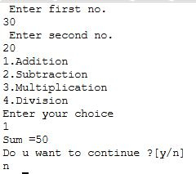

2)EVEN OR NOT

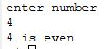

RESULT

Familiarized with the fundamentals of shell scripting.

STUDY OF LINUX SYSTEM CALLS
File Name | test.c  test2.c | Operating System | Linux
Experiment No | 3
Date | 24.5.2021
Aim | - Implement a program to create a child process using system call fork() and to understand the usage of the system calls getpid(), getppid(),exec(),sleep(),wait()  II) Implement a program to list all files in a directory/opening a directory
THEORETICAL BACKGROUND:
I) UNIX PROCESS: Process is an entity that executes a given piece of code, has its own execution stack, its own set of memory pages, its own file descriptors table, and a unique process ID. A unique process ID is allocated to each process when it is created . The data type of process id is pid_t. The pid_t data type is a signed integer type which is capable of representing a process ID.
Function: pid_t getpid (void) : The getpid function returns the process ID of the current process.
Function: pid_t getppid (void): The getppid function returns the process ID of the parent of the current process. (this is also known as the parent process ID).
Process ID (PID): Every process has a unique process ID or PID. The PID is an integer typically in the range 0 through 30000.The kernel assigns the PID when a new process is created and a process can obtain its PID using the getpid system call.
Syntax: int getpid();
The process with process ID 1 is a special process called the init process. Process ID 0 is also a special kernel process termed either the swapper or the scheduler. On virtual memory implementations of Unix the process with process ID 2 is typically a kernel process termed as page daemon
Parent Process ID (PPID): Every process has a parent process and a corresponding parent process ID. The kernel assigns the aprent process ID when a new process is created and a process can obtain its value using the getppid system call
Syntax: int getppid();
SYSTEM CALL
A system call is a direct entry point through which an active process can obtain services from the kernel. The system calls are specific routines in the operating system kernel that are directly accessible to application programs and are used to manage the file system, control processes, and to provide interprocess communication.
GENERAL CLASS SPECIFIC CLASS SYSTEM CALL
File Structure Creating a Channel creat()
Related Calls open()
close()
Input/Output read()
write()
Random Access lseek()
Process Related Process Creation and execve()
Calls Termination fork()
wait()

File Structure Related System Calls either use a character string that defines the absolute or relative path name of a file, or a small integer called a file descriptor that identifies the I/O channel. A channel is a connection between a process and a file that appears to the process as an unformatted stream of bytes. The kernel presents and accepts data from the channel as a process reads and writes that channel.
All input and output operations start by opening a file using either the "creat()" or "open()" system calls. These calls return a file descriptor that identifies the I/O channel. File descriptors 0, 1, and 2 refer to standard input, standard output, and standard error files respectively.
creat()
The prototype for the creat() system call is:
int creat(file_name, mode)
char *file_name;
int mode;
where file_name is pointer to a null terminated character string thatnames the file and mode defines the file's access permissions.
open()
The prototype for the open() system call is:
#include <fcntl.h>
int open(file_name, option_flags [, mode])
char *file_name;
int option_flags, mode;
where file_name is a pointer to the character string that names thefile, option_flags represent the type of channel, and mode defines thefile's access permissions if the file is being created.
close()
To close a channel, use the close() system call. The prototype for theclose() system call is:
int close(file_descriptor)
int file_descriptor;
where file_descriptor identifies a currently open channel.
lseek()
The prototype for lseek() is:
long lseek(file_descriptor, offset, whence)
int file_descriptor;
long offset;
int whence;
where file_descriptor identifies the I/O channel and offset and whencework together to describe how to change the file pointer according tothe following table:
whence new position
0 offset bytes into the file
1 current position in the file plus offset
2 current end-of-file position plus offset
Process Related System Calls
Four system calls are provided for creating a process, ending a process, and waiting for a process to complete. These system calls are fork(), the "exec" family, wait(), and exit(). The UNIX system calls that transform a executable binary file into a process are the "exec" family of system calls.
fork()
To create a new process, you must use the fork() system call. The prototype forthe fork() system call is:
int fork()
fork() causes the UNIX system to create a new process, called the "child process", with a new process ID. The contents of the child process are identical to the contents of the parent process.
wait()
wait() forces the parent to suspend execution until the child is finished. wait() returns the process ID of a child process that finished.If the child finishes before the parent gets around to calling wait(),then when wait() is called by the parent, it will return immediately with the child's process ID. (It is possible to have more than one child process by simply calling fork() more than once.).
The prototype for the wait() system call is:
int wait(status)
int *status;
where status is a pointer to an integer where the UNIX system storesthe value returned by the child process. wait() returns the process ID of theprocess that ended.
execve()
In computing, exec is a functionality of an operating system that runs an executable file in the context of an already existing process, replacing the previous executable. This act is also referred to as an overlay. As a new process is not created, the process identifier (PID) does not change, but the machine code, data, heap, and stack of the process are replaced by those of the new program. Linux kernel has the corresponding system call named "execve"
The fork() System Call
The fork() system call is the basic way to create a new process. It is declared in the header file unistd.h.
pid_t fork (void)
fork() causes the UNIX system to create a new process, called the ‘child process’, with a new process ID. The contents of the child process are identical to the contents of the parent process. If the operation is successful, there are then both parent and child processes and both see fork return, but with different values: it returns a value of 0 in the child process and returns the child's process ID in the parent process. If process creation failed, fork returns a value of -1 in the parent process. The child process and the parent process run in separate memory spaces.
execlp( ): Used after the fork() system call by one of the two processes to replace the process memory space with a new program. It loads a binary file into memory destroying the memory image of the program containing the execlp system call and starts its execution.The child process overlays its address space with the UNIX command /bin/ls using the execlp system call.
Syntax : execlp( )

wait( ) The parent waits for the child process to complete using the wait system call. The wait system call returns the process identifier of a terminated child, so that the parent can tell which of its possibly many children has terminated.
Syntax : wait( NULL)
exit( ) A process terminates when it finishes executing its final statement and asks the operating system to delete it by using the exit system call. At that point, the process may return data (output) to its parent process (via the wait system call).
Syntax: exit(0)
II) Different file system types may have different directory entries. The dirent structure defines a file system independent directory entry, which contains information common to directory entries in different file system types.
The dirent structure is defined as:
#include<sys/dirent.h>
struct dirent
{
long d_ino; /* inode number */
off_t d_off; /* offset to the next dirent */
unsigned short d_reclen; /* length of this record */
unsigned char d_type; /* type of file */
char d_name[256]; /* filename*/
};

d_ino inode number of a file
d_offset offset of that directory entry in the actual file system directory
d_name name of the file or directory
d_reclen record length of this entry
d_type type of file( text file, block file, directory etc)
ALGORITHM

1 a)To create child process and print process id and parent process id

- Start the process
- Declare a variable ‘p’ to be shared by both child and parent.
- Create a child process using fork system call and get its return value to ‘p’.
- If return value is -1 then
    - Print "Process creation unsuccessfull"
    - Terminate using exit system call.
- If return value is 0 then
    - Print "Child process"
    - Print process id of the child using getpid system call
    - Print process id of the parent using getppid system call
- Otherwise
    - Print "Parent process"
    - Print process id of the parent using getpid system call
    - Print process id of the shell using getppid system call.
- Stop the process

PROGRAM

#include <stdio.h>
#include <unistd.h>
#include <sys/types.h>

int main()
{
int i,p;
printf("\n pid=%d,ppid=%d\n",getpid(),getppid());
p=fork();
if(p==0)
{
printf("\nI am child process, pid=%d,ppid=%d",getpid(),getppid());
for(i=0;i<3;i++)
{
printf("\nChild process running");

}
printf("\nChild Exited");

}
else if(p>0)
{
printf("\nI am parent process, pid=%d,ppid=%d",getpid(),getppid());

for(i=0;i<6;i++)
{
printf("\nParent process running");

}
}
else
printf("\nError in creating child process");

}

ALGORITHM

1 b) To create a child process and execute child process first and then execute parent process
- Start the process
- Declare a variable ‘p’ to be shared by both child and parent.
- Create a child process using fork system call and get its return value to ‘p’.
- If return value is -1 then
    - Print "Process creation unsuccessfull"
    - Terminate using exit system call.
- If return value is 0 then
    - Print "Child process running"
    - Print process id of the child using getpid system call
    - Print process id of the parent using getppid system call
- Otherwise
    - Print "Parent process running"
    - Print process id of the parent using getpid system call
    - Print process id of the shell using getppid system call.
- Stop the process

PROGRAM

#include <stdio.h>
#include <unistd.h>
#include <sys/types.h>

int main()
{
int i,p;
printf("\n pid=%d,ppid=%d\n",getpid(),getppid());
p=fork();
if(p==0)
{
printf("\nI am child process, pid=%d,ppid=%d",getpid(),getppid());
for(i=0;i<3;i++)
{
printf("\nChild process running");
sleep(2);

}
printf("\nChild Exited");
sleep(2);
}
else if(p>0)
{
wait();
printf("\nI am parent process, pid=%d,ppid=%d",getpid(),getppid());

for(i=0;i<6;i++)
{
printf("\nParent process running");
sleep(2);
}
}
else
printf("\nError in creating child process");

}

ALGORITHM
1 c) To load an executable program in a child processes exec system call.
If no. of command line arguments, then stop.

- Start the process
- Create a child process using fork system call.
- If return value is -1 then
    - Print "Process creation unsuccessfull"
    - Terminate using exit system call.
- If return value is > 0 then
    - Suspend parent process until child completes using wait system call
    - Print "Child Terminated".
    - Terminate the parent process.
- If return value is 0 then
    - Print "Child starts"
    - Load the program in the given path into child process using exec system call.
    - If return value of exec is negative then print the exception and stop.
    - Terminate the child process.
- Stop

PROGRAM

#include <stdio.h>
#include <sys/types.h>
#include <unistd.h>
#include <stdlib.h>
main(int argc, char*argv[])
{
pid_t pid;
int i;
if (argc != 3)
{
printf("\nInsufficient arguments to load program");
printf("\nUsage: ./a.out <path> <cmd>\n");
exit(-1);
}
switch(pid = fork())
{
case -1:
printf("Fork failed");
exit(-1);

case 0:
printf("Child process\n");
i = execl(argv[1], argv[2],0);
if (i < 0)
{
printf("%s program not loaded using exec system call\n", argv[2]);
exit(-1);
}
default:
wait(NULL);
printf("Child Terminated\n"); exit(0);
}
}

2. To create a program and to list all the files in the directory

ALGORITHM

Step 1: Import libraries
Step 2: Open directory stream using opendir() and store its reference to *dir of DIR type.
Step 3: Input source path to list all files and sub-directories. Store it in some variable say path.
Step 4: Initialize another variable of pointer to structure dirent type, say struct dirent *dp.
Step 5: Read next element from directory stream using dp=readdir(dirp) .
Step 6: Print current directory stream item name, using dp->d_name.
Step 7: Repeat steps 5 and 6 till dp!=NULL.
Step 8: Finally, close the directory stream pointed by dir variable.

PROGRAM

#include<stdio.h>
#include<dirent.h>
#include<stdlib.h>
void main()
{
DIR *dirp;
struct dirent *dp;
if((dirp=opendir("/home/user/krishnar "))==NULL)
{
printf("\n cannot open");
exit(1);
}
for(dp=readdir(dirp);dp!=NULL;dp=readdir(dirp))
{
if(dp->d_type==DT_REG)
printf("%s\n",dp->d_name);
}
closedir(dirp);
}

OUTPUT

1a)
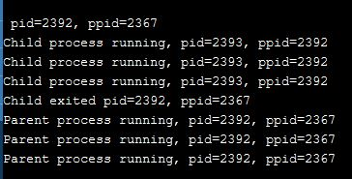

1b)
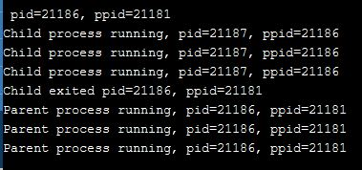

2)
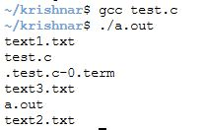

1c)

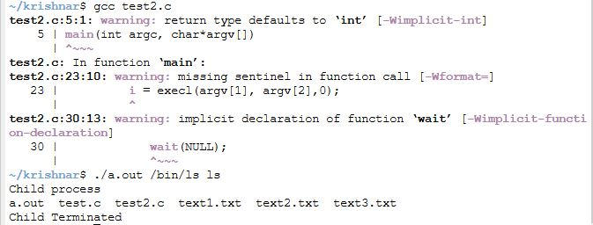

RESULT
Familiarized with linux system calls.

INTERPROCESS COMMUNICATION USING SHARED MEMORY
File Name | Test.c | Operating System | Linux
Experiment No | 4
Date | 31.5.2021
Aim | To make use of shared memory for interprocess communication
Theoretical Background:
Shared Memory is an efficient means of passing data between programs. One program will create a memory portion which other processes (if permitted) can access. A process creates a shared memory segment using shmget().Once created, a shared segment can be attached to a process address space using shmat(). It can be detached using shmdt().Once attached, the process can read or write to the segment, as allowed by the permission requested in the attach operation. A shared segment can be attached multiple times by the same process. A shared memory segment is described by a control structure with a unique ID that points to an area of physical memory. The identifier of the segment is called the shmid. The structure definition for the shared memory segment control structures and prototypes can be found in <sys/shm.h>.
Accessing a Shared Memory Segment
shmget() is used to obtain access to a shared memory segment. It is prototyped by:
int shmget(key_t key, size_t size, int shmflg);
The first argument to shmget() is the key value (returned by a call to ftok()).. The size argument is the size in bytes of the requested shared memory. The shmflg argument specifies the initial access permissions and creation control flags.
When the call succeeds, it returns the shared memory segment ID.
Attaching and Detaching a Shared Memory Segment
shmat() and shmdt() are used to attach and detach shared memory segments. Prototypes as follows:
void *shmat(int shmid, const void *shmaddr, int shmflg);
int shmdt(const void *shmaddr);

shmat() returns a pointer, shmaddr, to the head of the shared segment associated with a valid shmid. shmdt() detaches the shared memory segment located at the address indicated by shmaddr.
Algorithm:
Step 1: Start
Step 2: Generate a key using ftok function.
Step 3: Create a shared memory using shmget system call.
Step 4: Print the shared memory id.
Step 5: Attach shared memory to the process address space using shmat system call.
Step 6: Print the starting address of shared memory.
Step 7: Read a string from the keyboard.
Step 8: Copy the string to shared memory.
Step 9: Print the content of shared memory.
Step 10: Detach the shared memory using shmdt system call.

PROGRAM

#include<stdio.h>
#include<sys/types.h>
#include<sys/ipc.h>
#include<sys/shm.h>
#include<string.h>
#include<stdlib.h>
main()
{
int shmid;
int *val,val1;
char *bufc[100];
key_t key=ftok ("pipe.c",'a');
shmid = shmget(key , 40, IPC_CREAT|0777);
if (shmid<0)
printf ("ERROR");
printf("\nShared memory segment created with id=%d", shmid);

if ((val= shmat(shmid,0,0))<0)
{
printf ("ERROR");
}
else
{
printf ("\nSTARTING ADDRESS: %u", val);
printf ("\nENTER STRING TO BE WRITTEN:");
scanf ("%s",bufc);
strncpy (val, bufc, sizeof(bufc));
printf ("\nCONTENT OF MEMORY LOCATION: %s",val);
if ((val1 = shmdt (val))<0)
{
printf ("ERROR");
}
printf ("\nALLOCATED SHARED MEMORY DETACHED");
}
}
OUTPUT

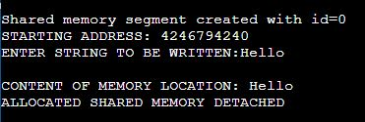

RESULT

C program to implement shared memory is executed successfully and output is obtained and verified.

PROCESS SCHEDULING
File Name | fcfs.c  priority.c  rr.c  sjf.c | Operating System | Linux
Experiment No | 5
Date | 14.6.2021
Aim | To simulate the following non-preemptive CPU scheduling algorithms to find turnaround time and waiting time.  a) FCFS b) Priority c) Round Robin (pre-emptive) d) SJF
Theoretical Background:
MULTIPROGRAMMING:
In a single-processor system, only one process can run at a time, others must wait until the CPU is free and can be rescheduled. The objective of multiprogramming is to have some process running at all times, thereby to maximize CPU utilization. CPU scheduling is the basis of multi-programmed systems. By switching the CPU among processes, the OS can make the computer more productive.
When a process waits for completion of an I/O request, CPU sits idle. All this waiting time is wasted; no useful work is accomplished. With multiprogramming, OS tries to use this time productively. Several processes are kept in memory at one time. When one process has to wait, the operating system takes the CPU away from that process and gives the CPU to another process.Maximum CPU utilization is obtained with multiprogramming.
PROCESS SCHEDULING:
The process scheduling is the activity of the process manager that handles the removal of the running process from the CPU and the selection of another process on the basis of a particular strategy. Process scheduling is an essential part of a multiprogramming operating systems. Such operating systems allow more than one process to be loaded into the executable memory at a time and the loaded process shares the CPU using time multiplexing.

TYPES OF SCHEDULING:
These are of two types of scheduling.
- Preemptive scheduling algorithms
- Non-Preemptive scheduling algorithms

Preemtive Scheduling algorithm: In this, the CPU can release the process even in the middle of execution. For example: the cpu executes the process p1, in the middle of execution the cpu received a request signal from process p2, then the OS compares the priorities of p1 & p2. If the priority p1 is higher than the p2 then the cpu continue the execution of process p1.Otherwise the cpu preempt the process p1 and assigned to process p2.

Non-Preemtive Scheduling algorithm: In this, once the CPU assigned to a process the processor do not release until the completion of that process. The cpu will assign to some other job only after the previous job has finished.

SCHEDULING CRITERIA:
Choice of a scheduling algorithm is based on:
- CPU Utilization: Percentage of time that the processor is busy.
  - keep the CPU as busy as possible
  - Range from 0 to 100 percent. (40% to 90% – lightly/heavily loaded)
- Throughput: number of processes that complete their execution per unit time.
  - Number of jobs completed per second.
  - Less throughput for longer processes, high throughput for shorter processes.
- Turnaround time: amount of time to execute a particular process.
  - Time interval between the submission of process and the time of completion.
Turn around time = waiting time in ready queue + executing time +
waiting time in waiting queue for I/O.
- Waiting time: amount of time a process has been waiting in ready queue
  - Sum of periods spent waiting by a process in the ready queue.
  - Algorithm with least average waiting time is said to be the best algorithm.
- Response time: amount of time it takes from when a request was submitted until the first response is produced, not output (for interactive time-sharing environment)
  - Time duration between the submission of job and first response.

Scheduling Algorithm Optimization Criteria
- Max CPU utilization
- Max throughput
- Min turnaround time
- Min waiting time
- Min response time

Calculations
- Average turn around time: (Avg TAT)
  - Turn around time = Finished time – Arrival time
  - Avg TAT= Total TAT of all processes / No of processes
- Average waiting time: (Avg WT)
  - Waiting time = Starting time – Arrival time [Consider all instances of execution]
  - Avg WT = Total WT of all processes / No of processes
- Average response time: (Avg RT)
  - Response time = First response – Arrival time
  - Avg RT= Total RT of all processes / No of processes

SCHEDULING ALGORITHMS:
A Process Scheduler schedules different processes to be assigned to the CPU based on particular scheduling algorithms. There are six popular process scheduling algorithms which we are going to discuss in this chapter −
- First-Come, First-Served (FCFS) Scheduling
- Shortest-Job-Next (SJN) Scheduling
- Priority Scheduling
- Shortest Remaining Time
- Round Robin(RR) Scheduling
- Multiple-Level Queues Scheduling
These algorithms are either non-preemptive or preemptive. Non-preemptive algorithms are designed so that once a process enters the running state, it cannot be preempted until it completes its allotted time, whereas the preemptive scheduling is based on priority where a scheduler may preempt a low priority running process anytime when a high priority process enters into a ready state.

(a) FIRST COME FIRST SERVE (FCFS)
FCFS is the simplest algorithm which is non preemptive. Processes gets CPU in the order they request it. There is a single FIFO queue of ready processes. When the first job enters the system, it is started immediately and allowed to run as long as it wants to. As other jobs come in, they are put onto the end of the ready queue. When the running process blocks, the next first process on the queue is run next. When a blocked process becomes ready, like a newly arrived job, it is put on the end of the queue.
(b) PRIORITY SCHEDULING
A priority number (integer) is associated with each process. The CPU is allocated to the process with the highest priority (smallest integer ≡ highest priority). SJF is priority scheduling where priority is the inverse of predicted next CPU burst time. Equal-priority processes are scheduled in FCFS order. Priorities are generally indicated by some fixed range of numbers, such as 0 to 7 or 0 to 4,095. We assume that low numbers represent high priority.
Two Schemes
Priority scheduling can be either preemptive or nonpreemptive.
- When a process arrives at the ready queue, its priority is compared with the priority of the currently running process.
- Preemptive: algorithm will preempt the CPU if the priority of the newly arrived process is higher than the priority of the currently running process.
Example - SJF: priority scheduling where priority is the predicted next CPU burst time.
- Nonpreemptive priority: algorithm will simply put the new process at the head of the ready queue.

Priorities can be defined either internally or externally. Internally defined priorities use some measurable quantity or quantities to compute the priority of a process. Time limits, memory requirements, the number of open files, and the ratio of average I/O burst to average CPU burst etc have been used in computing priorities. External priorities are set by criteria outside the OS. The importance of the process, the type and amount of funds being paid for computer use, the department sponsoring the work, and other, often political, factors.

(C) ROUND ROBIN SCHEDULING
RR scheduling is preemptive, simple, fair and widely used. It is similar to FCFS, but preemption is added to switch between processes. This scheduling is designed for time sharing systems. Each process is assigned a time interval, called its quantum or slice, generally 10 to 100 milliseconds in length, for which it is allowed to run. If the process is still running at the end of the quantum, the CPU is preempted and given to another. If the process has blocked or finished before the quantum has elapsed, the CPU switching is done.
The average waiting time under the RR policy is often long. Typically, higher average turnaround than SJF, but better response time.
(d) SHORTEST-JOB-FIRST SCHEDULING (SJF)
SJF scheduling ssumes that CPU run times are known in advance. Scheduler picks the shortest job first.
  - With each process, associate the length of its next CPU burst
  - Use these lengths to schedule the process with the shortest time
If two jobs have same burst time, FCFS is used to break the tie. SJF scheduling is used frequently in long-term scheduling.
Shortest-next-CPU-burst algorithm: Scheduling depends on the length of the next CPU burst of a process, rather than its total length.
Algorithm:
FCFS Scheduling:
Step 1: Start the process
Step 2: Accept the number of processes in the ready Queue
Step 3: For each process in the ready Q, assign the process id and accept the CPU burst time
Step 4: Set the waiting of the first process as ‘0’ and its burst time as its turn around time
Step 5: for each process in the Ready Q calculate
- Waiting time for process(n) = waiting time of process(n-1) + Burst time of process(n-1)
- Turn around time for Process(n) = waiting time of Process(n) + Burst time for process (n)
Step 6: For each process executed, print Gantt Chart data: process id, burst time, start time and end time of all the processes.
Step 7: Calculate and print the
- Average waiting time = Total waiting Time / Number of process
- Average Turnaround time = Total Turnaround Time / Number of process Step Step 8: Stop the process

Priority Scheduling:
Step 1: Start the process
Step 2: Accept the number of processes in the ready Queue
Step 3: For each process in the ready Q, assign the process id and accept the CPU burst time and priority value
Step 4: Sort the ready queue according to the priority number.
Step 5: Set the waiting of the first process as ‘0’ and its burst time as its turn around time
Step 6: For each process in the Ready Q calculate
- Waiting time for process(n)= waiting time of process (n-1) + Burst time of process(n-1)
- Turn around time for Process(n)= waiting time of Process(n)+ Burst time for process(n)
Step 7: For each process executed, print Gantt Chart data: process id, burst time, priority, start time and end time of all the processes.
Step 8: Calculate and print the
- Average waiting time = Total waiting Time / Number of process
- Average Turnaround time = Total Turnaround Time / Number of process Step Step 9: Stop the process

Round Robin Scheduling:
Step 1: Start the process
Step 2: Accept the number of processes in the ready Queue and time quantum (or)
time slice
Step 3: For each process in the ready Q, assign the process id and accept the CPU
burst time
Step 4: Calculate and save the process details such as total burst time, remaining
time and completion flag for each process.
Step 5: Reset waiting time and turnaround time for each process as zero.
Step 6: Consider the ready queue is a circular Q, for each process executed, print
Gantt Chart data. Do until the completion flag is set for all processes.
- If remaining time is less then quantum, set duration as remaining time,
turnaround time as (start time+duration), waiting time as (turnaround time-burst) and the set the completion flag to indicate that the process is finished.
Go to (b) otherwise
- Set duration as quantum time.
- Print the Gantt chart values in this round: process id, burst time, remaining time, start time and end time.
- Reset remaining time and stime time for next turn as (remaining time-duration) and (start time+duration) respectively.
- Move to step 6 (a) to continue with the next process in a round robin fashion.
Step 7: Print the waiting times and turn around times for each of the processes and
calculate the total waiting time and total average time.
Step 8: Calculate and print the
(a) Average waiting time = Total waiting Time / Number of process
    - (b) Average Turnaround time = Total Turnaround Time / Number of process
Step 9: Stop the process

SJF Scheduling:
Step 1: Start the process
Step 2: Accept the number of processes in the ready Queue
Step 3: For each process in the ready Q, assign the process id and accept the burst time.
Step 4: Sort the ready queue according to the ascending order of burst times.
Step 5: Set the waiting time of the first process as ‘0’ and its burst time as its turn around time
Step 6: For each process in the Ready Q calculate
- Waiting time for process(n)= waiting time of process (n-1) + Burst time of
process(n-1)
- Turn around time for Process(n)= waiting time of Process(n)+ Burst time for process(n)
Step 7: For each process executed, print Gantt Chart data: process id, burst time, priority, start time and end time of all the processes.
Step 8: Calculate and print the
- Average waiting time = Total waiting Time / Number of process
- Average Turnaround time = Total Turnaround Time / Number of process Step Step 9: Stop the process

PROGRAM

1)FCFS

#include<stdio.h>
void main()
{
int i,n,sum,wt,st,et,tat,twt,ttat,f,j;
int t[10],a[10];
float awt,atat;

printf("Enter number of processors:\n");
scanf("%d",&n);
for(i=0;i<n;i++)
{

printf("\n Enter the Arrival Time of the process %d:",i+1);
scanf("\n %d",&a[i]);
printf("\n Enter the Burst Time of the process %d:",i+1);
scanf("\n %d",&t[i]);
}
printf("\n\n FIRST COME FIRST SERVE SCHEDULING ALGORITHM \n");
printf("\n Process ID \t Burst Time \t Start Time \t End Time \n");
printf("1 \t\t %d \t\t 0 \t\t %d",t[0],t[0]);
sum=0;
twt=0;
ttat=t[0];
et=t[0];
for(i=1;i<n;i++)
{
sum+=t[i-1];
wt=sum-a[i];
tat=(sum+t[i])-a[i];
twt=twt+wt;
ttat=ttat+tat;
st=et;
et= et+t[i];

printf("\n %d \t\t %d \t\t %d\t\t %d",i+1,t[i],st,et);
printf("\n\n");

}
awt=(float)twt/n;
atat=(float)ttat/n;
printf("\n Waiting Time %d",twt);
printf("\n Turnaround Time %d",ttat);

printf("\n Average Waiting Time %4.2f",awt);
printf("\n Average Turnaround Time %4.2f",atat);

}

2)PRIORITY

#include <stdio.h>
#include <conio.h>
void main()
{
int i,j,n,a[10],tat,wt,bt[10],pid[10],pr[10],t,sum,twt,ttat=0,st,et,f;
float awt,atat;

printf("\nPRIORITY SCHEDULING\n");
printf("Enter the No of Process: ");
scanf("%d", &n);
for (i=0;i<n;i++)
{
pid[i] = i;
printf("Enter the Arrival time of Pid %d : ",i);
scanf("%d",&a[i]);
printf("Enter the Burst time of Pid %d : ",i);
scanf("%d",&bt[i]);
printf("Enter the Priority of Pid %d : ",i);
scanf ("%d",&pr[i]);
}

for (i=0;i<n;i++)
for(j=i+1;j<n;j++)
{
if (pr[i] > pr[j] )
{
t = pr[i];
pr[i] = pr[j];
pr[j] = t;
t = bt[i];
bt[i] = bt[j];
bt[j] = t;
t = pid[i];
pid[i] = pid[j];
pid[j] = t;
}
}
int l=pr[0];
printf("Pid\t Priority\tBurst time\t Starting Time\tEnd Time\n");
f=0;
sum=0;
twt=0;
ttat=10;
for(i=0;i<n;i++)
{
sum+=bt[i-1];
st=f;
et= st+bt[i];
wt=st-a[i];
tat=et-a[i];
twt=twt+wt;
ttat=ttat+tat;

f=f+bt[i];

printf("\n %d \t\t %d \t\t %d\t\t %d\t\t %d",pid[i],pr[i],bt[i],st,et);
printf("\n");

}

awt = (float)twt / n;
atat = (float)ttat / n;
printf("\n\nWaiting Time: %d\nTurn Around Time: %d\n",twt,ttat);
printf("\n\nAvg.Waiting Time: %f\nAvg.Turn Around Time: %f\n",awt,atat);

}

3)ROUND ROBIN

#include<stdio.h>
#include<conio.h>

void main()
{
// initlialize the variable name
int i, NOP, sum=0,count=0, y, quant, wt=0, tat=0, at[10], bt[10], temp[10];
float avg_wt, avg_tat;
printf(" Total number of process in the system: ");
scanf("%d", &NOP);
y = NOP; // Assign the number of process to variable y

// Use for loop to enter the details of the process like Arrival time and the Burst Time
for(i=0; i<NOP; i++)
{
printf("\n Enter the Arrival and Burst time of the Process[%d]\n", i+1);
printf(" Arrival time is: \t"); // Accept arrival time
scanf("%d", &at[i]);
printf(" \nBurst time is: \t"); // Accept the Burst time
scanf("%d", &bt[i]);
temp[i] = bt[i]; // store the burst time in temp array
}
// Accept the Time qunat
printf("Enter the Time Quantum for the process: \t");
scanf("%d", &quant);
// Display the process No, burst time, Turn Around Time and the waiting time
printf("\n Process No \t\t Burst Time \t\t TAT \t\t Waiting Time ");
for(sum=0, i = 0; y!=0; )
{
if(temp[i] <= quant && temp[i] > 0) // define the conditions
{
sum = sum + temp[i];
temp[i] = 0;
count=1;
}
else if(temp[i] > 0)
{
temp[i] = temp[i] - quant;
sum = sum + quant;
}
if(temp[i]==0 && count==1)
{
y--; //decrement the process no.
printf("\nProcess No[%d] \t\t %d\t\t\t\t %d\t\t\t %d", i+1, bt[i], sum-at[i], sum-at[i]-bt[i]);
wt = wt+sum-at[i]-bt[i];
tat = tat+sum-at[i];
count =0;
}
if(i==NOP-1)
{
i=0;
}
else if(at[i+1]<=sum)
{
i++;
}
else
{
i=0;
}
}
// represents the average waiting time and Turn Around time
avg_wt = wt * 1.0/NOP;
avg_tat = tat * 1.0/NOP;
printf("\n Average Turn Around Time: \t%f", avg_wt);
printf("\n Average Waiting Time: \t%f", avg_tat);
getch();
}

4)SJF

#include<stdio.h>
void main()
{
int i,j,k,n,sum,wt[10],tt[10],twt,ttat,st[10],et[10],a[10],f=0,m;
int t[10],p[10];
float awt,atat;

printf("Enter number of process\n");
scanf("%d",&n);
for(i=0;i<n;i++)
{p[i]=i;

printf("\n Enter the Burst Time of Process %d:",i);
scanf("\n %d",&t[i]);
}

for(i=0;i<n;i++)

for(k=i+1;k<n;k++)
{
if(t[i]>t[k])
{
int temp;
temp=t[i];
t[i]=t[k];
t[k]=temp;
temp=p[i];
p[i]=p[k];
p[k]=temp;
}
}
int l=t[0];
printf("\n\n SHORTEST JOB FIRST SCHEDULING ALGORITHM");
printf("\n PROCESS ID \t BURST TIME \t STARTING TIME \tENDING TIME \n\n");
sum=0;
for(i=0;i<n;i++)
{
sum+=t[i-1];
st[i]=f;
et[i]=st[i]+t[i];
f=et[i];
tt[i]=et[i];
wt[i]=tt[i]-t[i];
printf("%5d \t\t%d \t\t %d \t\t %d \n\n",p[i],t[i],st[i],et[i]);
}
twt=0;
ttat=0;
for(i=1;i<n;i++)
{
twt=twt+wt[i];
ttat=ttat+tt[i];
}
printf("\n WAITING TIME %d",twt);
printf("\n TURN AROUND TIME %d",ttat);
awt=(float)twt/n;
atat=(float)ttat/n;
printf("\n AVERAGE WAITING TIME %4.2f",awt);
printf("\n AVERAGE TURN AROUND TIME %4.2f",atat);

}

OUTPUT

1)FCFS
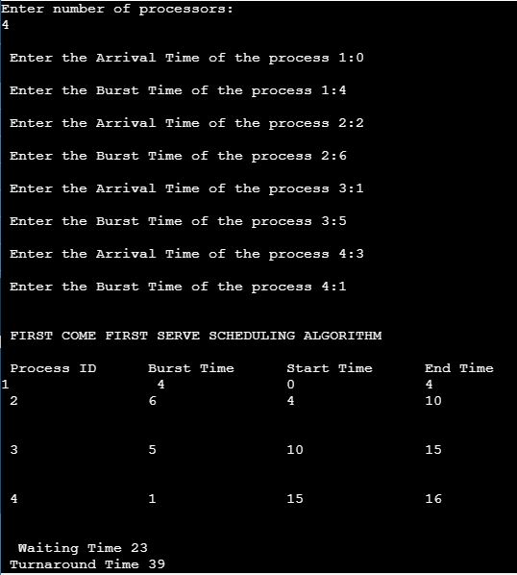
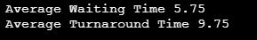

2) PRIORITY

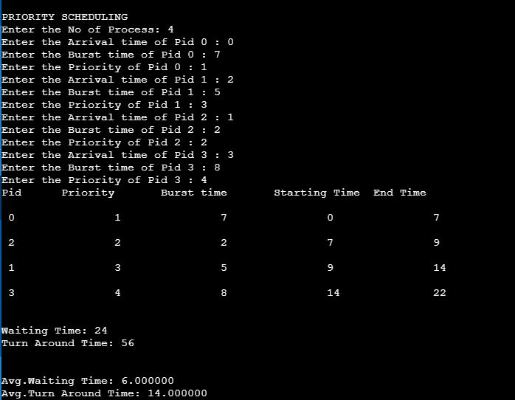

3)ROUND ROBIN

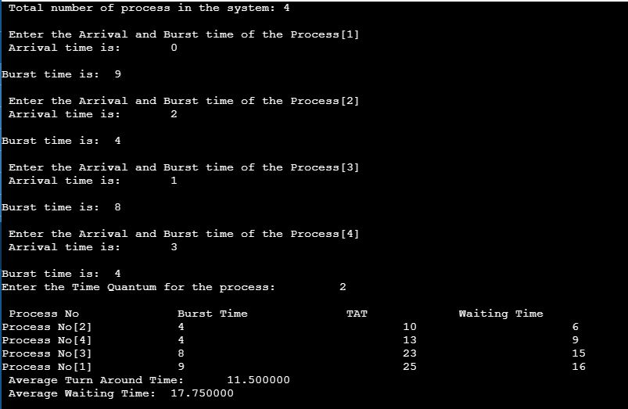

4)SJF

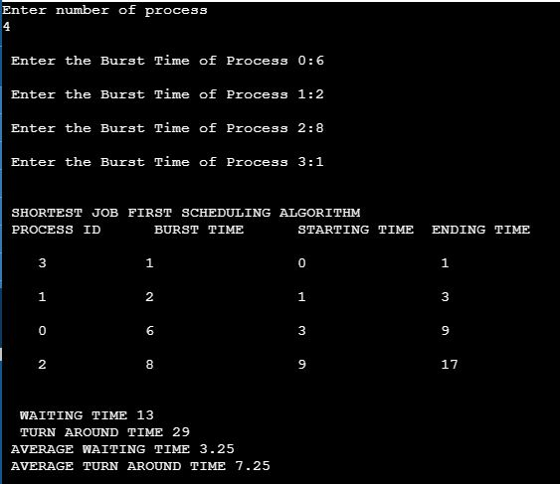

RESULT

C program to implement scheduling algorithms is executed successfully and output is obtained and verified.

SEMAPHORE OPERATIONS
File Name | Semaphore.c | Operating System | Linux
Experiment No | 6.a
Date | 09.8.2021
Aim | To create semaphores, set its value and perform semaphore operations.
i)
SEMAPHORE:
Semaphore is a method for Inter-Process Communication (IPC). It may be used to provide exclusive access to resources on the current machine, or to limit the number of processes that may simultaneously use a resource. i.e. it is a synchronization-tool. It is used to control access to shared-variables so that only one process may at any point in time change the value of the shared-variable.

A semaphore(S) is an integer-variable that is accessed only through 2 atomic-operations: wait() and signal(). wait() is termed P ("to test") and signal() is termed V ("to increment").
Definition of the wait() operation
wait(S) {
while (S <= 0)
; // busy wait while someone is already using
S--; //decrement and enter the c-s
}

Definition of the signal() operation
signal(S) {
S++; //increment and make it free for use
}

All modifications to the integer value of S in the wait() and signal() operations must be executed indivisibly. When one process modifies the semaphore-value, no other process can simultaneously modify that same semaphore-value. Also, in the case of wait(S), following 2 operations must be executed without interruption:
  - Testing of S(S<=0) and
  - Modification of S (S--)

Binary Semaphore: holds integer value of 0 and 1. Value 0 means semaphore is locked.
1 means it is unlocked.
- Can solve various synchronization problems using this.
Counting Semaphore: Integer value can range over an unrestricted domain.

IMPLEMENTATION USING C:
Semaphores are counters used to control access to shared resources by multiple processes. They are most often used as a locking mechanism to prevent processes from accessing a particular resource while another process is performing operations on it.

Creating a semaphore - semget():
A semaphore set is created by the semget system call, whose synopsis is:
#include <sys/types.h>
#include <sys/ipc.h>
#include <sys/sem.h>
int semget(key_t key, int nsems, int semflag);
This system call creates semaphore set and returns an integer id for the semaphore set or -1 in case of error.

- A key is implemented as an integer (whose size is specified by the key_t type), and a library function called ftok()used by different processes to identify the semaphore set.
#include <sys/ipc.h>
key_t ftok(const char *path, int id);
- The value of nsems specifies the number of semaphores in newly created semaphore set.
- The value of flag is a bit mask obtained ORing constants that specify:
  - The access permissions for the semaphore set, in the same way as for a file.
Upon creation, the least significant 9 bits of the argument semflg define the permissions (for owner, group and others) for the semaphore set.
  - The creation mode, can be:
    - IPC_PRIVATE
    - IPC_CREAT – creates a new semaphore set if it no existing semaphore set is associated with key, or point to the semaphore set if such a a set exists.

Data of Semaphore set - semid_ds structure:
For every set of semaphores in the system, the kernel maintains the following structure of information.
#include<sys/types.h>
#include<sys/ipc.h>
#include<sys/sem.h>
struct semid_ds{
struct ipc_prm sem_perm; /*operation permission struct*/
struct sem *sem_base; /*ptr to first semaphore in set*/
ushort sem_nsems; /*no of semaphores in the set*/
time_t sem_otime; /*time of last semop*/
time_t sem_ctime; /*time of last change*/
};
Data of each semaphore in a set - sem structure:
Internal data structure used by kernel to maintain the set of values for every member of a semaphore set.
struct sem
{
ushort semval; /* semaphore value, non negative*/
short sempid; /*pid of last operation*/
ushort semint; /* no of awaiting semval>cval*/
ushort semzcnt; /* no of awaiting semval=0*/
};

Setting and getting semaphore value - semctl():

#include <sys/types.h>

#include <sys/ipc.h>

#include <sys/sem.h>
int semctl(int semid, int semnum, int cmd, ...);
The semctl() function provides a variety of semaphore control operations as specified by cmd. The fourth argument is optional and depends upon the operation requested. If required, it is of type union semun.
union semun {
int val;
struct semid_ds *buf;
unsigned short *array;
} arg;
The following semaphore control operations as specified by cmd are executed with respect to the semaphore specified by semid and semnum. The symbolic names for the values of cmd are defined by the <sys/sem.h> header:
GETVAL: Return the value of semval.
SETVAL: Set the value of semval to arg.val, where arg is the value of the fourth argument to semctl().
IPC_RMID: Remove the semaphore-identifier specified by semid from the system and destroy the set of semaphores and semid_ds data structure associated with it.

Semaphore operations - Locking and unlocking a semaphore - semop():

#include <sys/types.h>

#include <sys/ipc.h>

#include <sys/sem.h>
int semop(int semid, struct sembuf *sops, size_t nsops);

The semop() function is used to perform atomically a user-defined array of semaphore operations on the set of semaphores associated with the semaphore identifier specified by the argument semid. i.e. semid is the id of the semaphore set on which the operations are to be performed. The argument sops is a pointer to a user-defined array of semaphore operation structures. The argument nsops is the number of such structures in the array. The sops argument points to an array of type sembuf. This structure is declared in linux/sem.h as follows:
struct sembuf{
unsigned short sem_num; /* semaphore number */
short sem_op; /* semaphore operation */
short sem_flg; /* operation flags */
};
Each of the nsops elements in the array pointed to by sops is a structure that specifies an operation to be performed on a single semaphore. The variable sem_op specifies one of three semaphore operations:
1 If sem_op is a positive integer, the operation adds this value to the semaphore value (semval).
2. If sem_op is less than zero the absolute value of sem_op is subtracted from semval.
3. If sem_op is zero, the process must have read access permission on the semaphore set.
PROGRAM
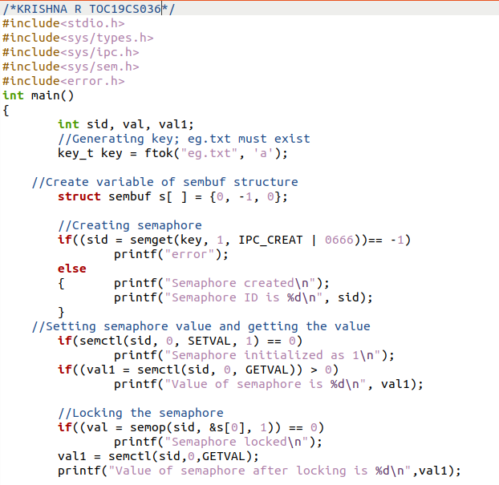

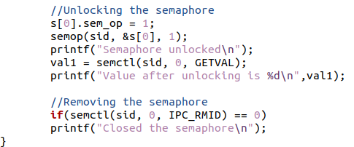

OUTPUT

1)
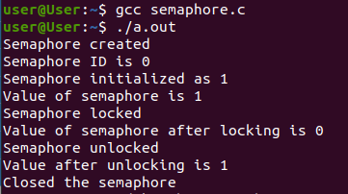

2)

RESULT

C program to implement scheduling algorithms is executed successfully and output is obtained and verified.

SOLVING PRODUCER CONSUMER PROBLEM USING SEMAPHORES
File Name | Producer.c | Operating System | Linux
Experiment No | 6.b
Date | 09.8.2021
Aim | To implement a C program to simulate producer consumer problem.
THEORY:
CRITICAL SECTION PROBLEM:
Consider system of n processes {p₀, p₁, … p_{n-1}}. Each process has critical section segment of code. Such a segment is a region of code where the shared resources are accessed – eg. changing common variables, updating table, writing file, etc. When one process in critical section, no other may be there; No two processes are executing in their c-s at the same time. Critical section problem is to design protocol to solve this. Each process must ask permission to enter critical section in entry section, critical section may follow with exit section, then remainder section.

General structure of process P_{i}
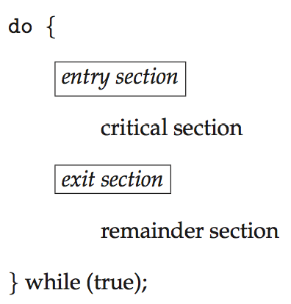

Solution to Critical-Section Problem
A solution to the c-s problem must satisfy the three requirements: mutual exclusion, progress and bounded wait.

THE BOUNDED-BUFFER PROBLEM (OR) PRODUCER CONSUMER PROBLEM:
The bounded-buffer problem is also known as the producer consumer problem. Two processes, Producer and Consumer are executing concurrently in a system. There is a pool of n buffers, each capable of holding one item. Producer and consumer share a common, fixed-size buffer (bounded buffer) to store and retrieve information.
- Producer puts (produces) information into the buffer and consumer takes it out (consumes).
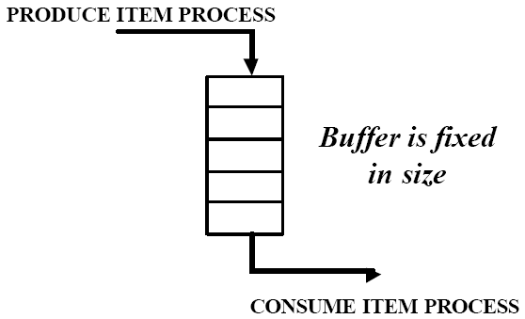
Fig: Bounded Buffer
- The operations of producer and consumer must be synchronized so that producer and consumer should not be allowed to access the buffer at the same time.
- Must ensure that the buffer does not over or underflow.
(1) Overflow: Producer wants to put a new item in buffer, but it is already full.
Producer goes to sleep and is awakened when the consumer has removed one or more items.
(2) Underflow: Consumer wants to remove an item from the buffer but the buffer is empty.
Consumer goes to sleep until the producer puts something in the buffer and wakes it up.

SEMAPHORE USAGE AND INITIALIZATION:
Three semaphores namely mutex, empty and full can be used to solve the bounded buffer problem.
The producer and consumer processes share the following data structures:
- A pool of n buffers, each can hold one item
- Semaphore mutex initialized to the value 1,
provides mutual exclusion for accesses to the buffer pool
- Semaphore full initialized to the value 0
count the number of full buffers; initially no items.
- Semaphore empty initialized to the value n
count the number of empty buffers; initially, all are empty.

int n;
semaphore mutex = 1;
semaphore empty = n;
semaphore full = 0

The case of producer producing full buffers for the consumer or as the consumer producing empty buffers for the producer is as described below.

The structure of the producer process:
do {
...
/* produce an item in next_produced */
...
wait(empty); //decrement empty count when producing
wait(mutex); //lock the c-s before producing to n
...
/* add next produced to the buffer */
...
signal(mutex); //release lock when exiting from c-s
signal(full); //increment full count when produced
} while (true);

The structure of the consumer process:
do {
wait(full); //decrement full count when consuming
wait(mutex); //lock the c-s before producing to n
...
/* remove an item from buffer to next_consumed */
...
signal(mutex); //release lock when exiting from c-s
signal(empty); //increment empty count when consumed
...
/* consume the item in next consumed */
...
} while (true);

Algorithm:
Step 1: Start the process
Step 2: Generate keys using ftok() and create semaphores mutex, empty and full using
semget()
Step 3: Initialize the semaphores; mutex as 1, full as 0 and empty as N using semctl()
Step 4: Create a child process using fork()
Step 5: If the process executing is parent, for i=1 to N, repeat steps 5.1 to 5.5 to produce items. Else go to Step 6.
Step 5.1: Decrement the empty count
Step 5.2: Decrement and lock mutex
Step 5.3: Produce i^{th} item to buffer
Step 5.4: Increment and unlock mutex
Step 5.5: Increment full count
Step 6: In child process, for i=1 to N, repeat steps 6.1 to 6.5 to consume items.
Step 6.1: Decrement the full count
Step 6.2: Decrement and lock mutex
Step 6.3: Consume i^{th} item from buffer
Step 6.4: Increment and unlock mutex
Step 6.5: Increment empty count
Step 7: Stop the process
PROGRAM

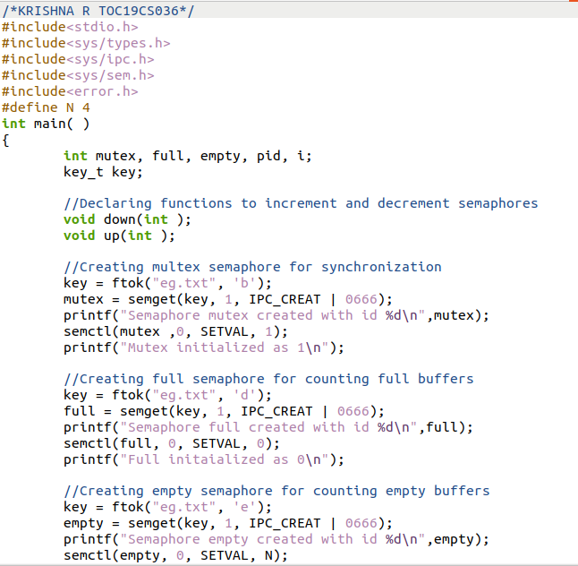

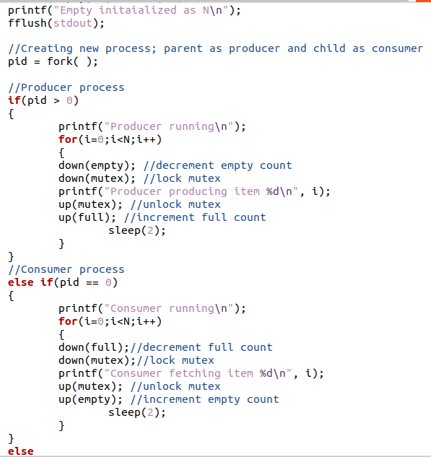

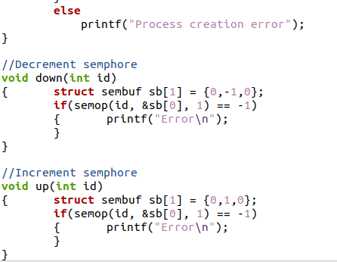

OUTPUT

1)

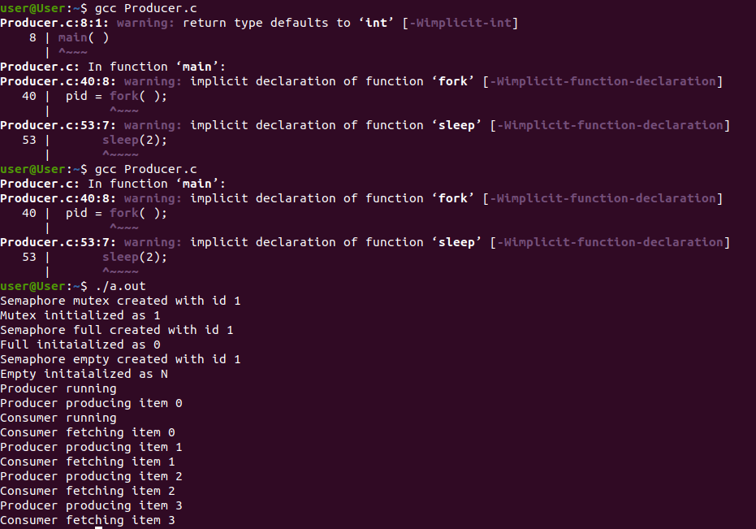

RESULT

C program to implement scheduling algorithms is executed successfully and output is obtained and verified.

BANKER’S ALGORITHM FOR DEADLOCK AVOIDANCE
File Name | Banker.c | Operating System | Linux
Experiment No | 7
Date | 6.9.2021
Aim | To implement a C program to simulate the banker’s algorithm for deadlock avoidance to find whether the system is in safe state or not.
DEADLOCK: In a multiprogramming environment, several processes may compete for a finite number of resources. A process requests resources; if the resources are not available at that time, the process enters a waiting state. Sometimes, a waiting process is never again able to change state, because the resources it has requested are held by other waiting processes. This situation is called a deadlock.
Necessary Conditions: A deadlock situation can arise if the following four conditions hold simultaneously in a system:
1. Mutual exclusion: At least one resource must be held in a non-sharable mode; that is, only one process at a time can use the resource. If another process requests that resource, the requesting process must be delayed until the resource has been released.
2. Hold and wait: A process must be holding at least one resource and waiting to acquire additional resources that are currently being held by other processes.
3. No preemption: Resources cannot be preempted; that is, a resource can be released only voluntarily by the process holding it, after that process has completed its task.
4. Circular wait: A set {P0, P1, ..., Pn} of waiting processes must exist such that P0 is waiting for a resource held by P1, P1 is waiting for a resource held by P2, ..., Pn-1 is waiting for a resource held by Pn, and Pn is waiting for a resource held by P0.
Methods for Handling Deadlocks
The deadlock problem can be dealt with in one of three ways:
  - Use a protocol to prevent or avoid deadlocks, ensuring that the system will never enter a deadlocked state.
  - Allow the system to enter a deadlocked state, detect it, and recover.
  - Ignore the problem altogether and pretend that deadlocks never occur in the system.
Deadlock Avoidance: Avoidance requires that the operating system be given additional information in advance concerning which resources a process will request and use during its lifetime. With this additional knowledge, the operating system can decide for each request whether or not the process should wait. To decide whether the current request can be satisfied or must be delayed, the system must consider the resources currently available, the resources currently allocated to each process, and the future requests and releases of each process.
- Simplest and most useful model
- Requires that the system has some additional a priori information
available regarding the resource usage.
- Requires that each process declare the maximum number of resources of each type that it may need.
- The deadlock-avoidance algorithm dynamically examines the resource-allocation state to ensure that there can never be a circular-wait condition.
- Resource-allocation state is defined by the resources currently available, the resources currently allocated to each process, and the future requests and releases of each process.

Deadlock Avoidance – Example: In a system with one tape drive and one printer, the system might need to know that process P will request first the tape drive and then the printer before releasing both resources, whereas process Q will request first the printer and then the tape drive. With this knowledge of the complete sequence of requests and releases for each process, the system can decide for each request whether or not the process should wait in order to avoid a possible future deadlock.
Safe State: When a process requests an available resource, system must decide if immediate allocation leaves the system in a safe state. A state is safe if the system can allocate resources to each process (up to its maximum) in some order and still avoid a deadlock. A system is in a safe state only if there exists a safe sequence.
Safe Sequence: A sequence of processes <P1, P2, …, Pn> is a safe sequence for the current allocation state if, for each Pi, the resource requests that Pi can still make can be satisfied by the currently available resources plus the resources held by all Pj, with j < i. That is: If P_{i} resource needs are not immediately available, then P_{i} can wait until all P_{j} have finished. When P_{j} is finished, P_{i} can obtain all the needed resources, execute, return allocated resources, and terminate. When P_{i} terminates, P_{i +1} can obtain its needed resources, and so on. If no such sequence exists, then the system state is said to be unsafe.
Safe State vs Deadlock: A safe state is not a deadlocked state. Conversely, a deadlocked state is an unsafe state. Not all unsafe states are deadlocks. An unsafe state may lead to a deadlock. As long as the state is safe, the OS can avoid unsafe (and deadlocked) states. Deadlock avoidance try to ensure that the system never enters an unsafe state.

Avoidance Algorithms: The idea is simply to ensure that the system will always remain in a safe state. Initially, the system is in a safe state. Whenever a process requests a resource that is currently available, the system must decide whether the resource can be allocated immediately or whether the process must wait. The request is granted only if the allocation leaves the system in a safe state. In this scheme, if a process requests a resource that is currently available, it may still have to wait. Thus, resource utilization may be lower than it would otherwise be.
  - Single instance of a resource type: Use a resource-allocation graph
  - Multiple instances of a resource type: Use the Banker’s algorithm
BANKER’S ALGORITHM:
For a system with multiple instances of each resource type, use Banker’s Algorithm for deadlock avoidance. The name was chosen because the algorithm could be used in a banking system to ensure that the bank never allocated its available cash in such a way that it could no longer satisfy the needs of all its customers. It is less efficient than the resource-allocation graph scheme. When a new process enters the system, it must declare the maximum no. of instances of each resource type that it may need. This may not exceed the total number of resources in the system. When a user requests a set of resources, the system must determine whether the allocation of these resources will leave the system in a safe state. If it will, the resources are allocated; otherwise, the process must wait until some other process releases enough resources.

Banker’s algorithm implementation needs several data structures to encode the state of the resource-allocation system.
- Let n is the number of processes in the system and m is the number of resource types:
- Available: A vector of length m indicates the number of available resources of each type.
  - If Available[j] equals k, then k instances of resource type Rj are available.
- Max: An n × m matrix defines the maximum demand of each process.
  - If Max[i][j] equals k, then process Pi may request at most k instances of resource type Rj.
- Allocation: An n × m matrix defines the number of resources of each type currently allocated to each process.
  - If Allocation[i][j] equals k, then process Pi is currently allocated k instances of resource type Rj .
- Need: An n × m matrix indicates the remaining resource need of each process.
  - If Need[i][j] equals k, then process Pi may need k more instances of resource type Rj to complete its task.
- Need[i][j] = Max[i][j] - Allocation[i][j]
These data structures vary over time in both size and value.

To simplify the presentation of the algorithm, establish some notations.
- Let X and Y be vectors of length n.
  - We say that X ≤ Y if and only if X[i] ≤ Y[i] for all i = 1, 2, ..., n.
    - ie., if X = (1,7,3,2) and Y = (0,3,2,1), then Y ≤ X.
  - In addition, Y < X if Y ≤ X and Y <> X.
- Treat each row in the matrices Allocation and Need as vectors and refer to them as Allocation_{i} and Need_{i} .
  - Allocation_{i} specifies the resources currently allocated to process Pi.
  - Need_{i} specifies the additional resources that process Pi may still request to complete its task.
a. Safety Algorithm:
Algorithm for finding out whether or not a system is in a safe state.

1. Let Work and Finish be vectors of length m and n, respectively.
Initialize
Work = Available (work vector is set as the number of resources available)
Finish[i] = false for i = 0, 1, ..., n − 1. (process finished or not, set to false)
2. Find an index i such that both
a. Finish[i] == false (find any process not finished, and
b. Need_{i} ≤ Work whose need is less than the available resources)
If no such i exists, go to step 4.
3. Work = Work + Allocation_{i} (add the freed up resources of Pi to work vector)
Finish[i] = true (mark process as finished)
Go to step 2. (iterate and find such processes one by one & allocate resources)
4. If Finish[i] == true for all i, then the system is in a safe state.
This algorithm require an order of m × n² operations to determine whether a state is safe.

b. Resource-Request Algorithm:
Algorithm for determining whether requests can be safely granted.

Let Request_{i} be the request vector for process Pi, i.e. the resources requested by the process.
If Request_{i} [j] == k, then process Pi wants k instances of resource type Rj.
When a resource request is made by process Pi, the following actions taken:
1. If Request_{i} ≤ Need_{i} , go to step 2.
Otherwise, raise an error condition (requesting for mare than its need), since the process has exceeded its maximum claim.
2. If Request_{i} ≤ Available, go to step 3.
Otherwise, Pi must wait, since the resources are not available.
3. Have the system pretend to have allocated the requested resources to process Pi by modifying the state as follows:
Available = Available – Request_{i} ;
Allocation_{i} = Allocation_{i} + Request_{i} ;
Need_{i} = Need_{i} – Request_{i} ;
If the resulting resource-allocation state is safe, (check using safety algorithm, the transaction is completed, and process Pi is allocated its resources.
However, if the new state is unsafe, then Pi must wait for Request_{i} , and the old resource-allocation state is restored.
EXAMPLE OF BANKER’S ALGORITHM:
Consider a system with 5 processes P0 through P4 and 3 resource types A, B, and C; Resource type A – 10 instances, Resource B – 5 instances, Resource C – 7 instances
Max – A(10), B(5), C(7)
Snapshot at time T₀:
Allocation Max Available
A B C A B C A B C
P₀ 0 1 0 7 5 3 3 3 2
P₁ 2 0 0 3 2 2
P₂ 3 0 2 9 0 2
P₃ 2 1 1 2 2 2
P₄ 0 0 2 4 3 3
- The matrix Need is defined to be (Max − Allocation )
Need Matrix Contents:
A B C
P₀ 7 4 3
P₁ 1 2 2
P₂ 6 0 0
P₃ 0 1 1
P₄ 4 3 1
The system is in a safe state since the sequence <P₁, P₃, P₄, P₂, P₀> satisfies safety criteria.

Suppose now that process P1 requests 1additional instance of resource type A and 2 instances of resource type C. Request₁ = (1,0,2)
To decide whether this request can be immediately granted, check that
Request₁ ≤ Available, (1,0,2) ≤ (3,3,2), which is true.

We must determine whether this new system state is safe?
- Execute safety algorithm and find that the sequence <P1, P3, P4, P0, P2> satisfies the safety requirement. Hence, we can immediately grant the request of process P1.
- Pretend that this request has been fulfilled, and we arrive at the following new state:
Allocation Need Available
A B C A B C A B C
P₀ 0 1 0 7 4 3 2 3 0
P₁ 3 0 2 0 2 0
P₂ 3 0 2 6 0 0
P₃ 2 1 1 0 1 1
P₄ 0 0 2 4 3 1
- Executing safety algorithm shows that sequence < P₁, P₃, P₄, P₀, P₂> satisfies safety requirement. Hence it can be allocated.

Algorithm:
Step1: Start the process
Step 2: Get the number of processes and number of resources
Step 3: Read the available number of instances for each resource
Step 4: Read the maximun resource count for each processes
Step 5: Read the allocated resource count for each processes
Step 6: Calculate for each process and resource, need = max – allocated
Step 7: Calculate the current available instances for each resource,
available – total allocated
Step 8: For each process Pi to Pn, check whether need < available, if yes do steps 8.1,
else increment i and go to step 8 to continue with the next process
Step 8.1: Allocate resources to Pi as per need and complete the execution of Pi
Step 8.2: Release all the resources allocated to Pi
Step 8.3: Mark the process as completed
Step 8.4: Update current available count as available+max for Pi
Step 9: If all process are completed successfully, print that the system is in safe state, else,
print that the system is not safe
Step 10: Stop the process
PROGRAM

#include <stdio.h>
#include <stdlib.h>
void final_output(int k[][10], int n, int p)
{
int i, j;
for (i = 0; i < n; i++)
{
printf("\n");
for (j = 0; j < p; j++)
{
printf("%d\t", k[i][j]);
}
}
}
//Banker's Algorithm
void Banker(int A[][10], int N[][10],
int M[10][10], int W[1][10], int *n, int *m)
{
int i, j;
printf("\n Enter total number of processes : ");
scanf("%d", n);
printf("\n Enter total number of resources : ");
scanf("%d", m);
for (i = 0; i < *n; i++)
{
printf("\n Process %d\n", i + 1);
for (j = 0; j < *m; j++)
{
printf(" Allocation for resource %d : ", j + 1);
scanf("%d", &A[i][j]);
printf(" Maximum for resource %d : ", j + 1);
scanf("%d", &M[i][j]);
}
}
printf("\n Available resources : \n");
for (i = 0; i < *m; i++)
{
printf(" Resource %d : ", i + 1);
scanf("%d", &W[0][i]);
}

for (i = 0; i < *n; i++)
for (j = 0; j < *m; j++)
N[i][j] = M[i][j] - A[i][j];

printf("\n ********Allocation Matrix**********");
final_output(A, *n, *m);
printf("\n ********Maximum Requirement Matrix"
"*********");
final_output(M, *n, *m);
printf("\n ***********Need Matrix*********");
final_output(N, *n, *m);
}
//Safety algorithm
int safety(int A[][10], int N[][10],
int B[1][10], int n, int m, int a[])
{

int i, j, k, x = 0, f1 = 0, f2 = 0;
int F[10], W[1][10];
for (i = 0; i < n; i++)
F[i] = 0;
for (i = 0; i < m; i++)
W[0][i] = B[0][i];

for (k = 0; k < n; k++)
{
for (i = 0; i < n; i++)
{
if (F[i] == 0)
{
f2 = 0;
for (j = 0; j < m; j++)
{
if (N[i][j] > W[0][j])
f2 = 1;
}
if (f2 == 0 && F[i] == 0)
{
for (j = 0; j < m; j++)
W[0][j] += A[i][j];
F[i] = 1;
f1++;
a[x++] = i;
}
}
}
if (f1 == n)
return 1;
}
return 0;
}
//Resource Request algorithm
void request(int A[10][10], int N[10][10]
, int B[10][10], int pid, int K)
{
int rmat[1][10];
int i;
printf("\n Enter additional request : \n");
for (i = 0; i < K; i++)
{
printf(" Request for resource %d : ", i + 1);
scanf("%d", &rmat[0][i]);
}

for (i = 0; i < K; i++)
if (rmat[0][i] > N[pid][i])
{
printf("\n ******Error encountered******\n");
exit(0);
}

for (i = 0; i < K; i++)
if (rmat[0][i] > B[0][i])
{
printf("\n ******Resources unavailable*****\n");
exit(0);
}

for (i = 0; i < K; i++)
{
B[0][i] -= rmat[0][i];
A[pid][i] += rmat[0][i];
N[pid][i] -= rmat[0][i];
}
}
int banker(int A[][10], int N[][10],
int W[1][10], int n, int m)
{
int j, i, a[10];
j = safety(A, N, W, n, m, a);
if (j != 0)
{
printf("\n\n");
printf("\n A safety sequence has been "
"detected.\n");
for (i = 0; i < n; i++)
printf(" P%d ", a[i]);
printf("\n");
return 1;
}
else
{
printf("\n Deadlock has occured.\n");
return 0;
}
}
int main()
{
int All[10][10], Max[10][10], Need[10][10]
, W[1][10];
int n, m, pid, c, r;
printf("\n *********DEADLOCK AVOIDANCE USING"
"BANKER'S ALGORITHM***********\n");
Banker(All, Need, Max, W, &n, &m);
r = banker(All, Need, W, n, m);
if (r != 0)
{
printf("\n Do you want make an additional"
"request for any of the process ? (1=Yes|0=No)");
scanf("%d", &c);
if (c == 1)
{
printf("\n Enter process number : ");
scanf("%d", &pid);
request(All, Need, W, pid - 1, m);
r = banker(All, Need, W, n, m);
if (r == 0)
{
exit(0);
}
}
}
else
exit(0);
return 0;
}
OUTPUT
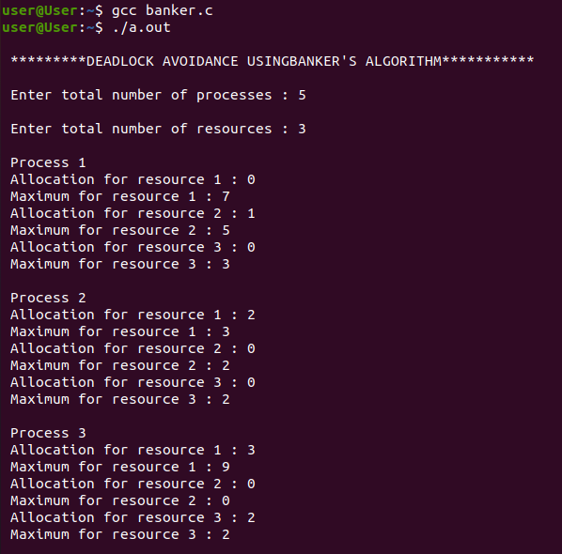

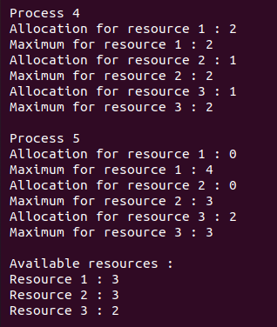

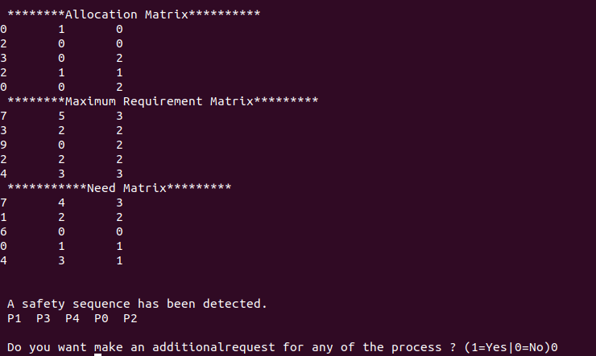

RESULT

The program to simulate Banker’s algorithm is executed and safe sequence is verified.

MEMORY MANAGEMENT
File Name | memory.c | Compiler | online gdb compiler
Experiment No | 8 | Data Structure | Array
Date | 5.10.2021
Aim | To implement first fit, best fit and worst fit memory management using c language.
Algorithm
Input:Let nb be the size of blocks and nf be the size of files.
Output:Files are allocated to the memory according to its size.
FIRST FIT
1. Repeat the steps for(i=1;i<=nf;i++)
1.1.Repeat the steps for j<=nb
1.1.1. if(bf[j]!=1) then
temp=b[j]-f[i]
if(temp>=0) then
ff[i]=j
1.2. frag[i]=temp
1.3. bf[ff[i]]=1
BEST FIT
1.Repeat the steps for(i=1;i<=nf;i++)
1.1.Repeat the steps for(j=1;j<=nb;j++)
1.1.1 if(bf[j]!=1) then
1.1.1.1 temp=b[j]-f[i]
1.1.1.2 if(temp>=0) then
1.1.1.3 if(lowest>temp) then
1.1.1.4ff[i]=j

1.1.1.5lowest=temp
1.2 frag[i]=lowest
1.3bf[ff[i]]=1
1.4lowest=10000
WORST FIT
1.Repeat the steps for(i=1;i<=nf;i++)
1.1.Repeat the steps for(j=1;j<=nb;j++)
1.1.1 if(bf[j]!=1) then //if bf[j] is not allocated
1.1.1.1.temp=b[j]-f[i]
1.1.1.2. if(temp>=0) then
1.1.1.3.if(highest<temp) then
a. ff[i]=j
b. highest=temp
1.2. frag[i]=highest
1.3.bf[ff[i]]=1
1.4.highest=0
Program

#include<stdio.h>
#include<conio.h>
#define max 25
void main()
{
int ch;
int frag[max],b[max],f[max],i,j,nb,nf,lowest=10000,highest=0,temp;
static int bf[max],ff[max];
do{
printf("\n1.FIRST FIT\n2.BEST FIT\n3.WORST FIT\n4.EXIT");
printf("\nEnter the choice:");
scanf("%d",&ch);

switch(ch)
{
case 1:
{
printf("\n\tMemory Management Scheme - First Fit");
printf("\nEnter the number of blocks:");
scanf("%d",&nb);
printf("Enter the number of files:");
scanf("%d",&nf);
printf("\nEnter the size of the blocks:-\n");
for(i=1;i<=nb;i++)
{
printf("Block %d:",i);
scanf("%d",&b[i]);
}
printf("Enter the size of the files :-\n");
for(i=1;i<=nf;i++)
{
printf("File %d:",i);
scanf("%d",&f[i]);
}
for(i=1;i<=nf;i++)
{
for(j=1;j<=nb;j++)
{
if(bf[j]!=1)
{
temp=b[j]-f[i];
if(temp>=0)
{
ff[i]=j;
break;
}
}
}
frag[i]=temp;
bf[ff[i]]=1;
}
printf("\nFile_no:\tFile_size :\tBlock_no:\tBlock_size:\tFragement");
for(i=1;i<=nf;i++)
printf("\n%d\t\t%d\t\t%d\t\t%d\t\t%d",i,f[i],ff[i],b[ff[i]],frag[i]);
//getch();
break;
}
case 2:
{
printf("\n\tMemory Management Scheme - Best Fit");
printf("\nEnter the number of blocks:");
scanf("%d",&nb);
printf("Enter the number of files:");
scanf("%d",&nf);
printf("\nEnter the size of the blocks:-\n");
for(i=1;i<=nb;i++)
{
printf("Block %d:",i);
scanf("%d",&b[i]);
}
printf("Enter the size of the files :-\n");
for(i=1;i<=nf;i++)
{
printf("File %d:",i);
scanf("%d",&f[i]);
}
for(i=1;i<=nf;i++)
{
for(j=1;j<=nb;j++)
{
if(bf[j]!=1)
{
temp=b[j]-f[i];
if(temp>=0)
if(lowest>temp)
{
ff[i]=j;

lowest=temp;
}
}
}
frag[i]=lowest;
bf[ff[i]]=1;
lowest=10000;
}
printf("\nFile No\tFile Size \tBlock No\tBlock Size\tFragment");
for(i=1;i<=nf && ff[i]!=0;i++)
printf("\n%d\t\t%d\t\t%d\t\t%d\t\t%d",i,f[i],ff[i],b[ff[i]],frag[i]);
getch();
break;
}
case 3:
{
printf("\n\tMemory Management Scheme - Worst Fit");
printf("\nEnter the number of blocks:");
scanf("%d",&nb);
printf("Enter the number of files:");
scanf("%d",&nf);
printf("\nEnter the size of the blocks:-\n");
for(i=1;i<=nb;i++)
{
printf("Block %d:",i);
scanf("%d",&b[i]);
}
printf("Enter the size of the files :-\n");
for(i=1;i<=nf;i++)
{
printf("File %d:",i);
scanf("%d",&f[i]);
}
for(i=1;i<=nf;i++)
{
for(j=1;j<=nb;j++)
{
if(bf[j]!=1) //if bf[j] is not allocated
{
temp=b[j]-f[i];
if(temp>=0)
if(highest<temp)
{
ff[i]=j;
highest=temp;
}
}
}
frag[i]=highest;
bf[ff[i]]=1;
highest=0;
}
printf("\nFile_no:\tFile_size :\tBlock_no:\tBlock_size:\tFragement");
for(i=1;i<=nf;i++)
printf("\n%d\t\t%d\t\t%d\t\t%d\t\t%d",i,f[i],ff[i],b[ff[i]],frag[i]);
getch();
break;
}
}
}
while(ch!=4);
{
return 0;
}
}
Output

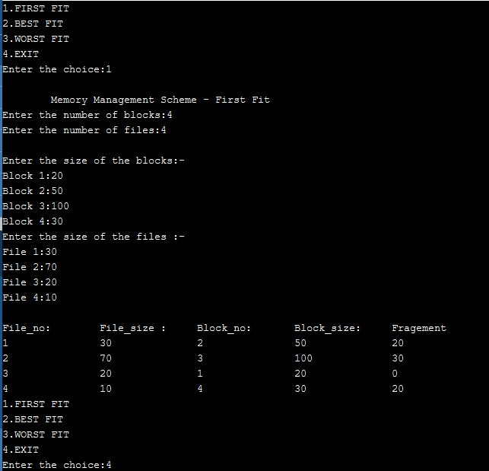

Result: The program was executed and output obtained successfully and was verified

PAGE REPLACEMENT ALGORITHMS
File Name | fifo.c  lru.c  lfu.c | Operating System | Linux
Experiment No | 9
Date | 23.9.2021
Aim | To develop a C program to simulate page replacement algorithms  a) FIFO b) LRU c) LFU
Theoretical Background:
Page replacement is basic to demand paging. It completes the separation between logical memory and physical memory. With this mechanism, an enormous virtual memory can be provided for programmers on a smaller physical memory. There are many different page-replacement algorithms. Every operating system probably has its own replacement scheme.
A FIFO replacement algorithm associates with each page the time when that page was brought into memory. When a page must be replaced, the oldest page is chosen. If the recent past is used as an approximation of the near future, then the page that has not been used for the longest period of time can be replaced. This approach is the Least Recently Used (LRU) algorithm. LRU replacement associates with each page the time of that page's last use. When a page must be replaced, LRU chooses the page that has not been used for the longest period of time. Least frequently used (LFU) page-replacement algorithm requires that the page with the smallest count be replaced. The reason for this selection is that an actively used page should have a large reference count.
PROGRAM

1.FIFO
/*FIFO PAGE REPLACEMENT*/
#include<stdio.h>
int main()
{
int i, j, k, f, pf=0, count=0, rs[25], m[10], n;
printf("\n FIFO Page Replacement");
printf("\n Enter the length of reference string: ");
scanf("%d",&n);
printf("\n Enter the reference string: ");
for(i=0;i<n;i++)
scanf("%d",&rs[i]);
printf("\n Enter no. of frames: ");
scanf("%d",&f);
for(i=0;i<f;i++)
m[i]=-1;
printf("\n The Page Replacement Process is -- \n");
for(i=0;i<n;i++)
{
for(k=0;k<f;k++)
{
if(m[k]==rs[i])
break;
}
if(k==f)
{
m[count++]=rs[i];
pf++;
}
for(j=0;j<f;j++)
printf("\t%d",m[j]);
if(k==f)
printf("\tPF No. %d",pf);
printf("\n");
if(count==f)
count=0;
}
printf("\n The number of Page Faults using FIFO are %d",pf);
}
2.LRU
/*LRU PAGE REPLACEMENT*/
#include<stdio.h>
int main()
{
int i, j , k, min, rs[25], m[10], count[10], flag[25], n, f, pf=0, next=1;
printf("\n LRU Page Replacement");
printf("\n Enter the length of reference string: ");
scanf("%d",&n);
printf(" Enter the reference string -- ");
for(i=0;i<n;i++)
{
scanf("%d",&rs[i]);
flag[i]=0;
}
printf(" Enter the number of frames -- ");
scanf("%d",&f);
for(i=0;i<f;i++)
{
count[i]=0;
m[i]=-1;
}
printf("\n The Page Replacement process is -- \n");
for(i=0;i<n;i++)
{
for(j=0;j<f;j++)
{
if(m[j]==rs[i])
{
flag[i]=1;
count[j]=next;
next++;
}
}
if(flag[i]==0)
{
if(i<f)
{
m[i]=rs[i];
count[i]=next;
next++;
}
else
{
min=0;
for(j=1;j<f;j++)
if(count[min] > count[j])
min=j;
m[min]=rs[i];
count[min]=next;
next++;
}
pf++;
}
for(j=0;j<f;j++)
printf("%d\t", m[j]);
if(flag[i]==0)
printf("PF No. %d" , pf);
printf("\n");
}
printf("\n The number of page faults using LRU are %d",pf);
}

3.LFU
/* Program to simulate optimal page replacement */
#include<stdio.h>
int fr[3], n, m;
void display();
int main()
{
int i,j,page[20],fs[10];
int max,found=0,lg[3],indx,k,l,flag1=0,flag2=0,pf=0;
float pr;
printf("OPTIMAL PAGE REPLACEMENT\n");
printf("Enter length of the reference string: ");
scanf("%d",&n);
printf("Enter the reference string: ");
for(i=0;i<n;i++)
scanf("%d",&page[i]);
printf("Enter no of frames: ");
scanf("%d",&m);
for(i=0;i<m;i++)
fr[i]=-1;
pf=m;
for(j=0;j<n;j++)
{
flag1=0;
flag2=0;
for(i=0;i<m;i++)
{
if(fr[i]==page[j])
{
flag1=1;
flag2=1;
break;
}
}
if(flag1==0)
{
for(i=0;i<m;i++)
{
if(fr[i]==-1)
{
fr[i]=page[j];
flag2=1;
break;
}
}
}
if(flag2==0)
{
for(i=0;i<m;i++)
lg[i]=0;
for(i=0;i<m;i++)
{
for(k=j+1;k<=n;k++)
{
if(fr[i]==page[k])
{
lg[i]=k-j; break;
}
}
}
found=0;
for(i=0;i<m;i++)
{
if(lg[i]==0)
{
indx=i;
found = 1;
break;
}
}
if(found==0)
{
max=lg[0];
indx=0;
for(i=0;i<m;i++)
{
if(max<lg[i])
{
max=lg[i];
indx=i;
}
}
}
fr[indx]=page[j];
pf++;
}
display();
}
printf("Number of page faults : %d\n", pf); pr=(float)pf/n*100;
printf("Page fault rate = %f \n", pr);
}
void display()
{
int i;
for(i=0;i<m;i++)
printf("%d\t",fr[i]);
printf("\n");
}

OUTPUT
1.FIFO
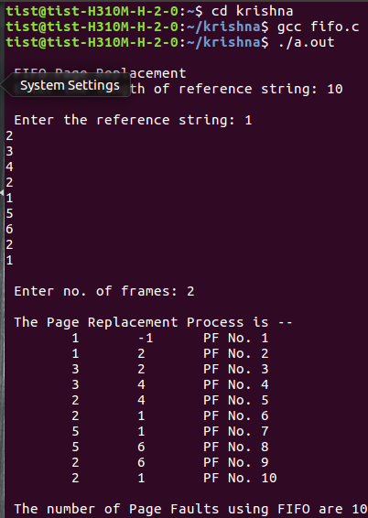

2.LRU
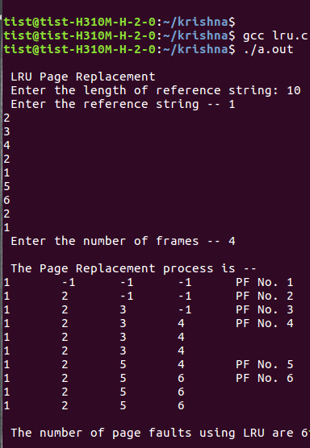

3.LFU
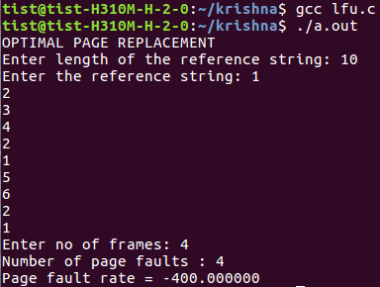

RESULT

Implemented programs to simulate page replacement algorithms and verified.

DISK SCHEDULING
File Name | fcfs.c  scan.c  cscan.c | Operating System | Linux
Experiment No | 10
Date | 23.9.2021
Aim | Implement programs to simulate the following disk scheduling algorithms.  a) FCFS b)SCAN c) C-SCAN
Theoretical Background:
Disks provide a bilk of secondary storage. Disks come in various sizes, speed and information can be stored optically or magnetically.
Disk scheduling algorithms schedule the order of disk I/Os to maximize performance. Disk Scheduling is the process of deciding which of the cylinder request is in the ready queue is to be accessed next. The access time and the bandwidth can be improved by scheduling the servicing of disk I/O requests in good order.
Access Time: The access time has two major components: Seek time and Rotational Latency.
Seek Time: Seek time is the time for disk arm to move the heads to the cylinder containing the desired sector.
Rotational Latency: Rotational latency is the additional time waiting for the disk to rotate the desired sector to the disk head.
Bandwidth: The disk bandwidth is the total number of bytes transferred, divided by the total time between the first request for service and the completion of the last transfer.

Different types of scheduling algorithms are as follows:

FCFS scheduling algorithm:This is the simplest form of disk scheduling algorithm. This services the request in the order they are received. This algorithm is fair but do not provide fastest service. It takes no special time to minimize the overall seek time.
Eg:-consider a disk queue with request for i/o to blocks on cylinders. 98, 183, 37, 122, 14, 124, 65, 67
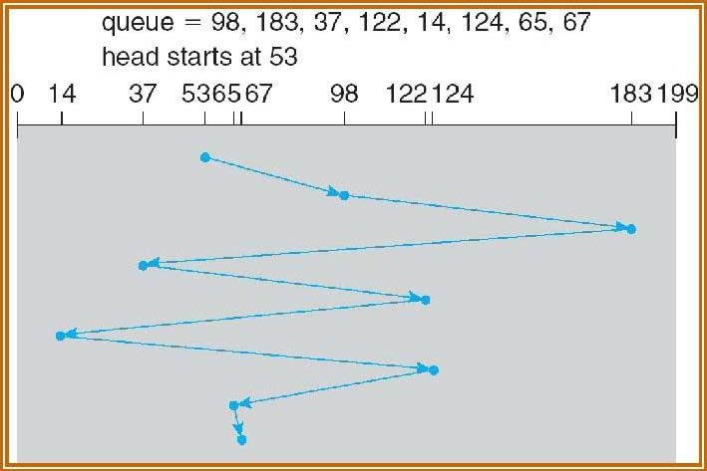

If the disk head is initially at 53, it will first move from 53 to 98 then to 183 and then to 37, 122, 14, 124, 65, 67 for a total head movement of 640 cylinders. The wild swing from 122 to 14 and then back to 124 illustrates the problem with this schedule. If the requests for cylinders 37 and 14 could be serviced together before or after 122 and 124 the total head movement could be decreased substantially and performance could be improved.

SSTF ( Shortest seek time first) algorithm:This selects the request with minimum seek time from the current head position. Since seek time increases with the number of cylinders traversed by head, SSTF chooses the pending request closest to the current head position. Eg:-consider a disk queue with request for i/o to blocks on cylinders. 98, 183, 37, 122, 14, 124, 65, 67
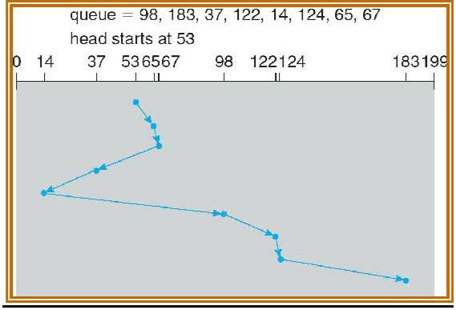
If the disk head is initially at 53, the closest is at cylinder 65, then 67, then 37 is closer then 98 to 67. So it services 37, continuing we service 14, 98, 122, 124 and finally 183. The total head movement is only 236 cylinders. SSTF is essentially a form of SJF and it may cause starvation of some requests. SSTF is a substantial improvement over FCFS, it is not optimal.

SCAN algorithm:In this the disk arm starts at one end of the disk and moves towards the other end, servicing the request as it reaches each cylinder until it gets to the other end of the disk. At the other end, the direction of the head movement is reversed and servicing continues. Eg:-:-consider a disk queue with request for i/o to blocks on cylinders. 98, 183, 37, 122, 14, 124, 65, 67

If the disk head is initially at 53 and if the head is moving towards 0, it services 37 and then 14. At cylinder 0 the arm will reverse and will move towards the other end of the disk servicing 65, 67, 98, 122, 124 and 183. If a request arrives just in from of head, it will be serviced immediately and the request just behind the head will have to wait until the arms reach other end and reverses direction. The SCAN is also called as elevator algorithm.

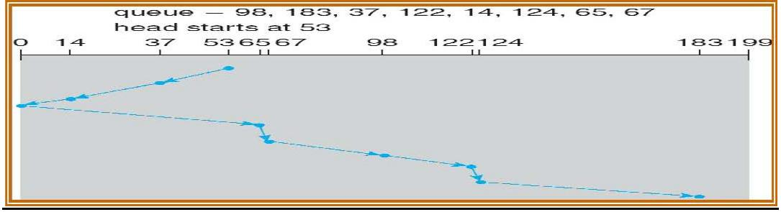

C-SCAN (Circular scan) algorithm:
C-SCAN is a variant of SCAN designed to provide a more uniform wait time. Like SCAN, C- SCAN moves the head from end of the disk to the other servicing the request along the way. When the head reaches the other end, it immediately returns to the beginning of the disk, without servicing any request on the return. The C-SCAN treats the cylinders as circular list that wraps around from the final cylinder to the first one. Eg:-

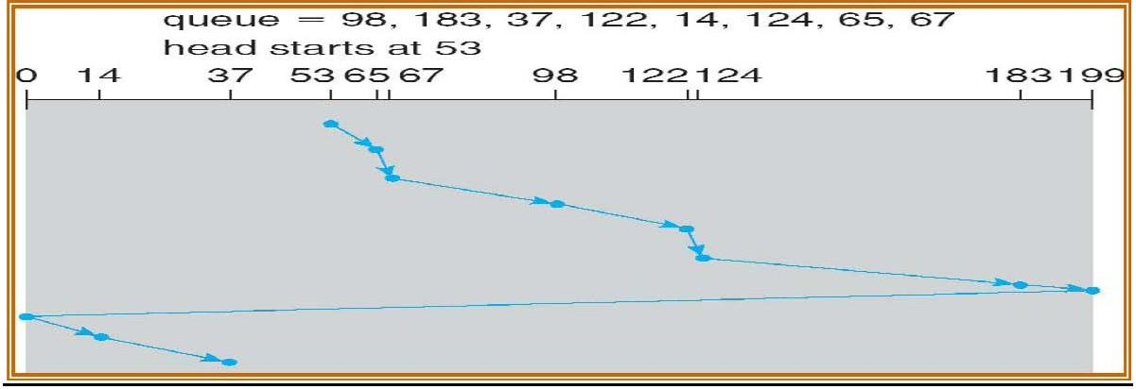

LOOK Scheduling algorithm:
Both SCAN and C-SCAN move the disk arm across the full width of the disk. In practice neither of the algorithms is implemented in this way. The arm goes only as far as the final request in each direction. Then it reverses, without going all the way to the end of the disk. These versions of SCAN and CSCAN are called Look and C-Look scheduling because they look for a request before continuing to move in a given direction. Eg:

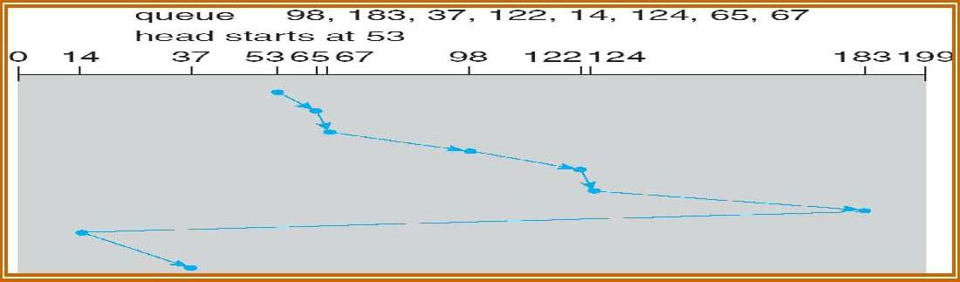

Selection of Disk Scheduling Algorithm:
- SSTF is common and it increases performance over FCFS.
- SCAN and C-SCAN algorithm is better for a heavy load on disk.
- SCAN and C-SCAN have less starvation problem.
- SSTF or Look is a reasonable choice for a default algorithm.
Algorithm:
- Start the process
- Input the maximum number of cylinders and work queue
- Imput the disk head starting position and previous position
- FCFS Scheduling: The operations are performed in order requested.
- Scan from the first request till the last request
- Compute the seek time as the sum of absolute disk movements
- SCAN Scheduling:
- Sort the request work queue in order
- Check the previous position to find out right scan or leaft scan to be performed
- Accordingly, start at the current position and move the disk head to the last request in the direction, servicing each of them
- Then move to the farther end and start back servising the requests towards other direction
- Compute seek time by adding up the head movements
- C-SCAN Scheduling:
- Sort the request work queue in order
- Check the previous position to find out right scan or leaft scan to be performed
- Accordingly, start at the current position and move the disk head to the last request in the direction
- Then move to the farther end in the current direction and move back to the farther end in the opposite direction
- Start back with the requests towards the same direction
- Compute seek time by adding up the head movements
- Stop the process
PROGRAM

1.FCFS
#include<stdio.h>
#include<stdlib.h>
int main()
{
int RQ[100],i,n,TotalHeadMoment=0,initial;
printf("Enter the number of Requests\n");
scanf("%d",&n);
printf("Enter the Requests sequence\n");
for(i=0;i<n;i++)
scanf("%d",&RQ[i]);
printf("Enter initial head position\n");
scanf("%d",&initial);

// logic for FCFS disk scheduling

for(i=0;i<n;i++)
{
TotalHeadMoment=TotalHeadMoment+abs(RQ[i]-initial);
initial=RQ[i];
}

printf("Total head moment is %d\n",TotalHeadMoment);
return 0;

}
2.SCAN
#include<stdio.h>
#include<stdlib.h>
int main()
{
int RQ[100],i,j,n,TotalHeadMoment=0,initial,size,move;
printf("Enter the number of Requests\n");
scanf("%d",&n);
printf("Enter the Requests sequence\n");
for(i=0;i<n;i++)
scanf("%d",&RQ[i]);
printf("Enter initial head position\n");
scanf("%d",&initial);
printf("Enter total disk size\n");
scanf("%d",&size);
printf("Enter the head movement direction for high 1 and for low 0\n");
scanf("%d",&move);

// logic for Scan disk scheduling

/*logic for sort the request array */
for(i=0;i<n;i++)
{
for(j=0;j<n-i-1;j++)
{
if(RQ[j]>RQ[j+1])
{
int temp;
temp=RQ[j];
RQ[j]=RQ[j+1];
RQ[j+1]=temp;
}

}
}

int index;
for(i=0;i<n;i++)
{
if(initial<RQ[i])
{
index=i;
break;
}
}

// if movement is towards high value
if(move==1)
{
for(i=index;i<n;i++)
{
TotalHeadMoment=TotalHeadMoment+abs(RQ[i]-initial);
initial=RQ[i];
}
// last movement for max size
TotalHeadMoment=TotalHeadMoment+abs(size-RQ[i-1]-1);
initial = size-1;
for(i=index-1;i>=0;i--)
{
TotalHeadMoment=TotalHeadMoment+abs(RQ[i]-initial);
initial=RQ[i];

}
}
// if movement is towards low value
else
{
for(i=index-1;i>=0;i--)
{
TotalHeadMoment=TotalHeadMoment+abs(RQ[i]-initial);
initial=RQ[i];
}
// last movement for min size
TotalHeadMoment=TotalHeadMoment+abs(RQ[i+1]-0);
initial =0;
for(i=index;i<n;i++)
{
TotalHeadMoment=TotalHeadMoment+abs(RQ[i]-initial);
initial=RQ[i];

}
}

printf("Total head movement is %d",TotalHeadMoment);
return 0;
}

3.CSCAN
#include<stdio.h>
#include<stdlib.h>
int main()
{
int RQ[100],i,j,n,TotalHeadMoment=0,initial,size,move;
printf("Enter the number of Requests\n");
scanf("%d",&n);
printf("Enter the Requests sequence\n");
for(i=0;i<n;i++)
scanf("%d",&RQ[i]);
printf("Enter initial head position\n");
scanf("%d",&initial);
printf("Enter total disk size\n");
scanf("%d",&size);
printf("Enter the head movement direction for high 1 and for low 0\n");
scanf("%d",&move);

// logic for C-Scan disk scheduling

/*logic for sort the request array */
for(i=0;i<n;i++)
{
for( j=0;j<n-i-1;j++)
{
if(RQ[j]>RQ[j+1])
{
int temp;
temp=RQ[j];
RQ[j]=RQ[j+1];
RQ[j+1]=temp;
}

}
}

int index;
for(i=0;i<n;i++)
{
if(initial<RQ[i])
{
index=i;
break;
}
}

// if movement is towards high value
if(move==1)
{
for(i=index;i<n;i++)
{
TotalHeadMoment=TotalHeadMoment+abs(RQ[i]-initial);
initial=RQ[i];
}
// last movement for max size
TotalHeadMoment=TotalHeadMoment+abs(size-RQ[i-1]-1);
/*movement max to min disk */
TotalHeadMoment=TotalHeadMoment+abs(size-1-0);
initial=0;
for( i=0;i<index;i++)
{
TotalHeadMoment=TotalHeadMoment+abs(RQ[i]-initial);
initial=RQ[i];

}
}
// if movement is towards low value
else
{
for(i=index-1;i>=0;i--)
{
TotalHeadMoment=TotalHeadMoment+abs(RQ[i]-initial);
initial=RQ[i];
}
// last movement for min size
TotalHeadMoment=TotalHeadMoment+abs(RQ[i+1]-0);
/*movement min to max disk */
TotalHeadMoment=TotalHeadMoment+abs(size-1-0);
initial =size-1;
for(i=n-1;i>=index;i--)
{
TotalHeadMoment=TotalHeadMoment+abs(RQ[i]-initial);
initial=RQ[i];

}
}

printf("Total head movement is %d",TotalHeadMoment);
return 0;
}
OUTPUT
1.FCFS
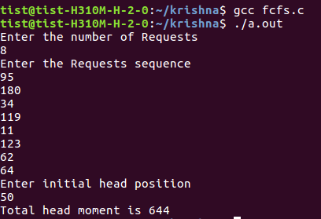

2.SCAN
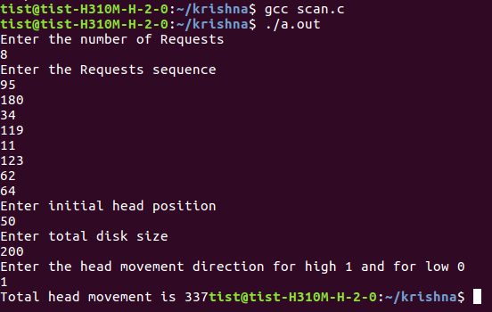

3.CSCAN
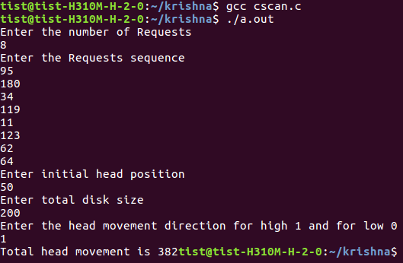

RESULT

The disk scheduling algorithms, FCFS, SCAN and C-SCAN are simulated and the seek times are verified.

FILE ALLOCATION STRATEGY
File Name | sequential.c  indexed.c  linked.c | Operating System | Linux
Experiment No | 11
Date | 5.10.2021
Aim | Implement programs to simulate the following file allocation algorithms.  a) Sequential b)Indexed c) Linked
PROGRAM

1.Sequential

#include <stdio.h>

#include <stdlib.h>
void recurse(int files[]){
int flag = 0, startBlock, len, j, k, ch;
printf("Enter the starting block and the length of the files: ");
scanf("%d%d", &startBlock, &len);
for (j=startBlock; j<(startBlock+len); j++){
if (files[j] == 0)
flag++;
}
if(len == flag){
for (int k=startBlock; k<(startBlock+len); k++){
if (files[k] == 0){
files[k] = 1;
printf("%d\t%d\n", k, files[k]);
}
}
if (k != (startBlock+len-1))
printf("The file is allocated to the disk\n");
}
else
printf("The file is not allocated to the disk\n");
printf("Do you want to enter more files?\n");
printf("Press 1 for YES, 0 for NO: ");
scanf("%d", &ch);
if (ch == 1)
recurse(files);
else
exit(0);
return;
}
int main()
{
int files[50];
for(int i=0;i<50;i++)
files[i]=0;
printf("Files Allocated are :\n");
recurse(files);

return 0;
}
2.Indexed
#include <stdio.h>

#include <stdlib.h>
int files[50], indexBlock[50], indBlock, n;
void recurse1();
void recurse2();
void recurse1(){
printf("Enter the index block: ");
scanf("%d", &indBlock);
if (files[indBlock] != 1){
printf("Enter the number of blocks and the number of files needed for the index %d on the disk: ", indBlock);
scanf("%d", &n);
}
else{
printf("%d is already allocated\n", indBlock);
recurse1();
}
recurse2();
}
void recurse2(){
int ch;
int flag = 0;
for (int i=0; i<n; i++){
scanf("%d", &indexBlock[i]);
if (files[indexBlock[i]] == 0)
flag++;
}
if (flag == n){
for (int j=0; j<n; j++){
files[indexBlock[j]] = 1;
}
printf("Allocated\n");
printf("File Indexed\n");
for (int k=0; k<n; k++){
printf("%d ------> %d : %d\n", indBlock, indexBlock[k], files[indexBlock[k]]);
}
}
else{
printf("File in the index is already allocated\n");
printf("Enter another indexed file\n");
recurse2();
}
printf("Do you want to enter more files?\n");
printf("Enter 1 for Yes, Enter 0 for No: ");
scanf("%d", &ch);
if (ch == 1)
recurse1();
else
exit(0);
return;
}
int main()
{
for(int i=0;i<50;i++)
files[i]=0;
recurse1();
return 0;
}

3.Linked
#include <stdio.h>

#include <stdlib.h>
void recursivePart(int pages[]){
int st, len, k, c, j;
printf("Enter the index of the starting block and its length: ");
scanf("%d%d", &st, &len);
k = len;
if (pages[st] == 0){
for (j = st; j < (st + k); j++){
if (pages[j] == 0){
pages[j] = 1;
printf("%d------>%d\n", j, pages[j]);
}
else {
printf("The block %d is already allocated \n", j);
k++;
}
}
}
else
printf("The block %d is already allocated \n", st);
printf("Do you want to enter more files? \n");
printf("Enter 1 for Yes, Enter 0 for No: ");
scanf("%d", &c);
if (c==1)
recursivePart(pages);
else
exit(0);
return;
}
int main(){
int pages[50], p, a;
for (int i = 0; i < 50; i++)
pages[i] = 0;
printf("Enter the number of blocks already allocated: ");
scanf("%d", &p);
printf("Enter the blocks already allocated: ");
for (int i = 0; i < p; i++){
scanf("%d", &a);
pages[a] = 1;
}
recursivePart(pages);

return 0;
}

OUTPUT
1.Sequential
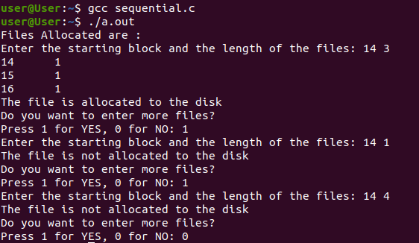

2.Indexed
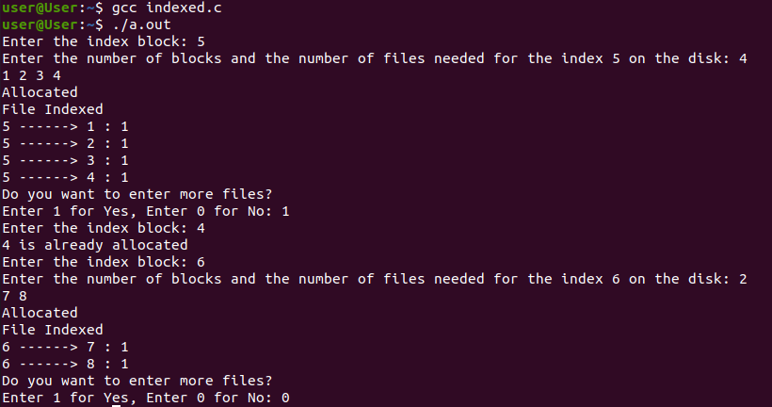

3.Linked
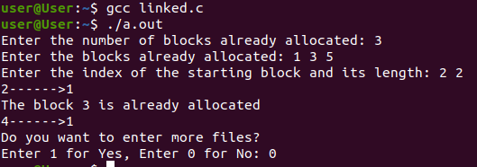

RESULT

The file allocation algorithms, sequential, indexed and linked are simulated and verified.

